|  |  |
| --- | --- |
| *Pacific Gas and Electric Company* | |
| Release 9.2 Installation Guide | |
|  |  |
|  |  |
| Project | ED AM/GIS |
|  |  |
| Prepared by | Subhankar Baidya |
| Date | 12/9/2014 |
| Version | 1.0 |
| Version Type | Final |

|  |  |  |  |
| --- | --- | --- | --- |
| Revision History | | | |
| Document # | Date | Author | Summary of Changes |
| 1.0 |  | Subhankar Baidya | Initial Document Creation |

# Introduction

## Purpose

This document is intended to detail the implementation and configuration steps required to implement Release 9.1 Installation Guide. This document describes the various configuration aspects required to complete any manual or automatic patch associated with this release. Each section in this document contains the steps required to patch the system in production.

## Terms Used

|  |  |
| --- | --- |
| OOTB | Out of the box. Unmodified from the commercial version. |
| TFS | Team Foundation Server |

## External Documents

Referenced are any external configuration documents or exports. These are documents that contain more detailed information about configuring a system or documents that can be loaded into an application to perform the configuration detailed in this document.



1. Generation table creation script
   1. \\sfetgis-nas01\sfgispoc_data\ApplicationDevelopment\IBM_Delivery\ReleaseInstructions\9.2\Release 9.2 Scripts\generation scripts

## List of Fixes

Below is the list of change requests detailing all fixes for the data model for this release:

|  |  |  |
| --- | --- | --- |
| **Item Number** | | **Title** |
| [17684](http://edappgistfsprd1:8080/tfs/web/wi.aspx?pcguid=15e9a9d1-95cb-4dd0-abfe-5af14ae6201f&id=17684) | | Master TFS Data Model 9.1 |
| [16229](http://edappgistfsprd1:8080/tfs/web/wi.aspx?pcguid=15e9a9d1-95cb-4dd0-abfe-5af14ae6201f&id=16229) | DA Issue: Remove Structure Size domain from Vault Subtype |
| [17223](http://edappgistfsprd1:8080/tfs/web/wi.aspx?pcguid=15e9a9d1-95cb-4dd0-abfe-5af14ae6201f&id=17223) | Remove relationships between Transformer and Switch, Transformer and Network Protector |
| [17686](http://edappgistfsprd1:8080/tfs/web/wi.aspx?pcguid=15e9a9d1-95cb-4dd0-abfe-5af14ae6201f&id=17686) | Change Domain Conductor Insulation - UG " Code "Lead Rubber" to "R&L" |
| [17687](http://edappgistfsprd1:8080/tfs/web/wi.aspx?pcguid=15e9a9d1-95cb-4dd0-abfe-5af14ae6201f&id=17687) | PAR 76087: Add New Pole Height Range Domain to Support Structure subtype "Tower" attribute "Height" |
| [17688](http://edappgistfsprd1:8080/tfs/web/wi.aspx?pcguid=15e9a9d1-95cb-4dd0-abfe-5af14ae6201f&id=17688) | Append Manhole Cover Size to the SubsurfaceStructure’s annotation for Vaults |
| [17689](http://edappgistfsprd1:8080/tfs/web/wi.aspx?pcguid=15e9a9d1-95cb-4dd0-abfe-5af14ae6201f&id=17689) | Bold SubsurfaceStructure and VaultPoly’s Structure Number annotation |
| 17747 | Add Local Office ID to UFM Features |
| 17884 | DCConductor 50 scale anno needs to be smaller |
| 17885 | Update DC Conductor Type Domain |
| 17979 | Clean-up unused UFM features/fields |
| 17981 | UFM Display Fields |
| 14631 | Assign PGE Preserve Relationship AU to EDGIS.DeactivatedElectricLineSegment feature class |
| 14657 | JP Number and JPA Sequence reverted to <Null> on new pole. Joint Pole District attribute is still copying over (FYI – Pacific Bell is NOT a Joint Pole District). |
| 14658 | Getting error message while updating voltage regulator phase designation |
|  | Create PGE Field Level Model Names |
|  | Create Table Level Model Names |
|  | Update the ‘Tenant Name’ Domain |
|  | Update Annotation Expression for StreetLightAnno |
|  | Update Annotation Expression for SupportStructureAnno |
|  | Update DynamicProtectiveDeviceAnno |
|  | Add the DuctCount field for EDGIS.PGEDuctDefinition (INC000003866881) |
|  | Add the ‘IS - Innovative Switchgear Solutions Inc’ value in Device Manufacture Domain(INC000003885629) |
|  | Apply Symbol Number Configuration to Switch Feature Class |
|  | Apply Symbol Number Configuration to Capacitor bank Feature Class |
|  | Update EDGIS.SubTransformerUnit table Configuration (INC000003926560) |
|  | Create new Domain and new Field for Primary Generation Feature Class |
|  | Apply ArcFM XML Configuration |
|  | Check JointOwner Configuration |
|  | Change PrimaryRiser Default Value for InstallJobNumber |
|  | Change Streetlight OWNERSHIP Field to Visible |
|  |  |
|  |  |

## Summary of Steps to Complete Install

Contents

1 Introduction 3

1.1 Purpose 3

1.2 Terms Used 3

1.3 External Documents 3

1.4 List Of Fixes 4

1.5 Summary of Steps to Complete Install 6

2 Open a Database Connection in ArcCatalog 9

3 16229 - DA Issue: Remove Structure Size domain from Vault Subtype 10

4 17223 - Remove relationships between Transformer and Switch, Transformer and Network Protector 11

5 17686 - Change Domain Conductor Insulation - UG " Code "Lead Rubber" to "R&L" 12

6 17687 - PAR 76087: Add New Pole Height Range Domain to Support Structure subtype "Tower" attribute "Height" 13

7 17688 - Append Manhole Cover Size to the SubsurfaceStructure’s annotation for Vaults 14

8 17689 - Bold SubsurfaceStructure and VaultPoly’s Structure Number annotation 15

9 17747 - Add Local Office ID to UFM Features 17

10 17884 - DCConductor 50 scale anno needs to be smaller 39

11 17885 - Update DC Conductor Type Domain 40

12 17979 - Clean-up unused UFM features/fields 45

13 17981 - UFM Display Fields 51

14 14631- Assign PGE Preserve Relationship AU to EDGIS.DeactivatedElectricLineSegment feature class 53

15 14657 - JP Number and JPA Sequence reverted to <Null> on new pole.  Joint Pole District attribute is still copying over (FYI – Pacific Bell is NOT a Joint Pole District). 55

16 14658 - Getting error message while updating voltage regulator phase designation 57

17 Create PGE Field Level Model Names 58

18 Create Table Level Model Names 59

19 Update the ‘Tenant Name’ Domain 60

20 Update Annotation Expression for StreetLightAnno 61

21 Update Annotation Expression for SupportStructureAnno 62

22 Update DynamicProtectiveDeviceAnno 64

23 Add the DuctCount field for EDGIS.PGEDuctDefinition (INC000003866881) 65

24 Add the ‘IS - Innovative Switchgear Solutions Inc’ value in Device Manufacture Domain(INC000003885629) 68

25 Apply Symbol Number Configuration to Switch Feature Class 72

26 Apply Symbol Number Configuration to Capacitor bank Feature Class 74

27 Update EDGIS.SubTransformerUnit table Configuration (INC000003926560) 76

28 Create new Domain and new Field for Primary Generation Feature Class 81

29 Apply ArcFM XML Configuration 86

30 Check JointOwner Configuration 89

31 Change PrimaryRiser Default Value for InstallJobNumber 92

32 Change Streetlight OWNERSHIP Field to Visible 93

33 Data Model Version Table 94

34 Known Issues 95

# Unzip attached “Release 9.2 Scripts.zip” file in the local machine.

1. Copy attached “Release 9.2 Scripts.zip” (section 1.3) in the local machine.
2. Unzip the file.

# Open a Database Connection in ArcCatalog

1. Open ArcCatalog.
2. Within the Catalog Tree, expand “Database Connections” and open the active connection for this process. This is the connection that is referenced in the change request associated with this document (EDGIS<DB name in the format X#Y> )

# Original Release 7.7.3

## 14631- Assign PGE Preserve Relationship AU to EDGIS.DeactivatedElectricLineSegment feature class

1. Expand EDGIS.ElectricDataset.
2. Right click on EDGIS.DeactivatedElectricLineSegment and select ArcFM Properties manager.

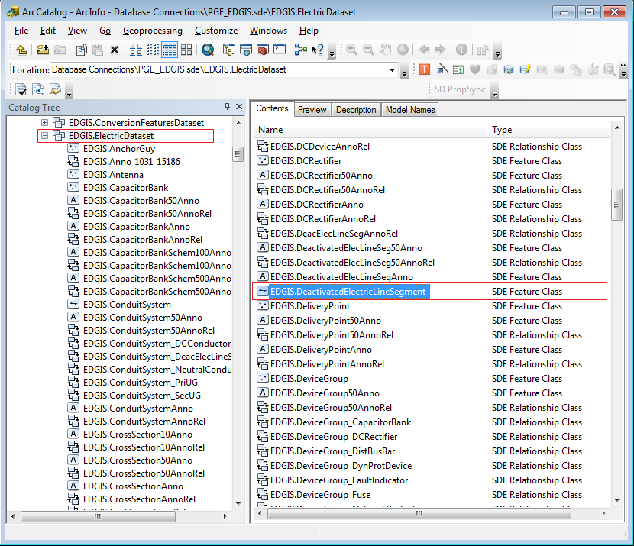

1. Go to Object Info tab.
2. Select PGE Preserve Relationship AU at "On Feature Create".

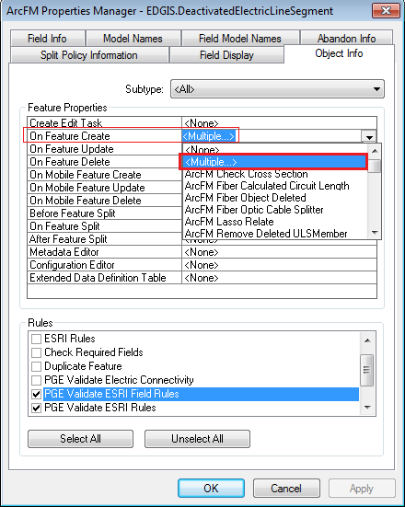

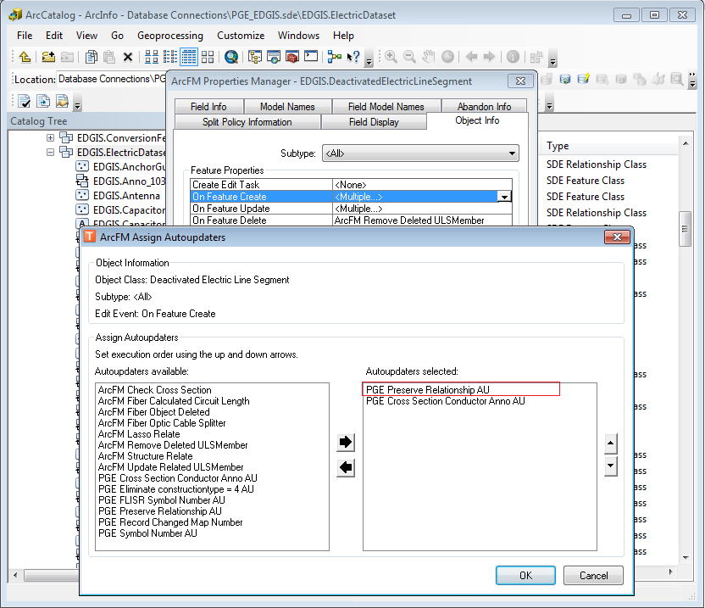

1. Click Apply. Click OK.

## 14657 - JP Number and JPA Sequence reverted to <Null> on new pole.  Joint Pole District attribute is still copying over (FYI – Pacific Bell is NOT a Joint Pole District).

1. In the ElectricDataset, right click the SupportStructure feature class and select ArcFM Properties Manager.

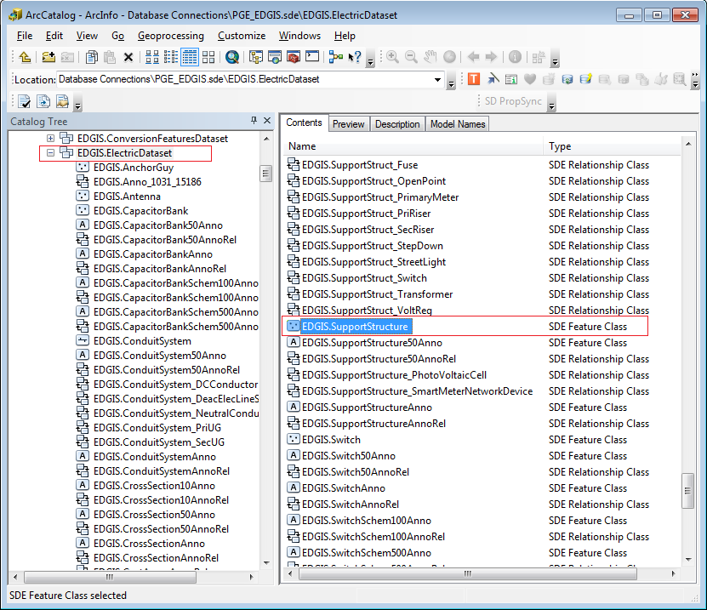

1. Select the Field Model Names tab and scroll down to the Joint Pole District field. Select it.
2. Double click PGE_ASSETCOPY on the right hand side box in the bottom right corner of the screen to unassign the field model name from the field.

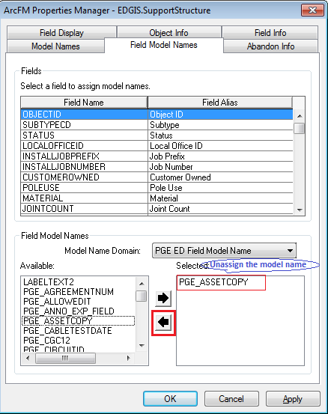

1. Click Apply. Click OK.

## 14658 - Getting error message while updating voltage regulator phase designation

1. At the root level, right click the Voltage Regulator Unit and select **ArcFM Properties Manager.**

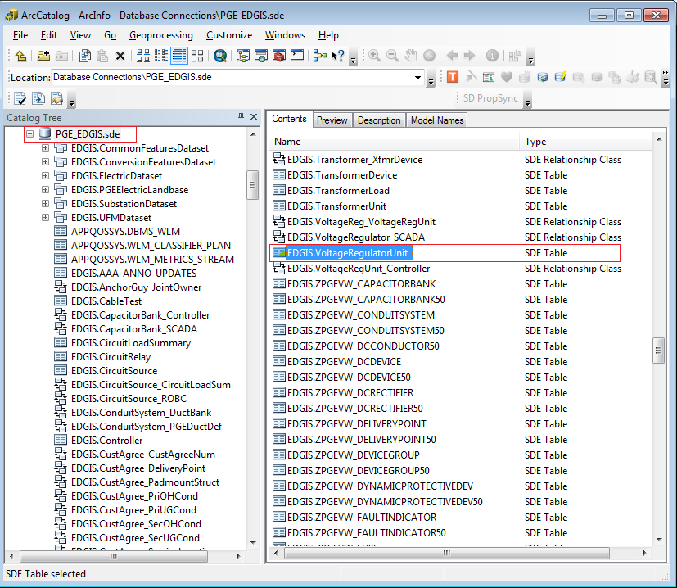

1. Select the **Object Info** tab.
2. Click the dropdown next to **On Feature Update** and select <Multiple>…
3. Double click “**ArcFM Synch Unit Phase Designation AU**” on the right hand side box to **unassign** the AU from the table.
4. Click Apply. Click OK.

## 14213 - PhotoVoltaicCell configuration

1. Gain exclusive access to the environment
2. Open ArcCatlog
3. Connect to EDGIS database as EDGIS user
4. Navigate to ‘EDGIS. PhotoVoltaicCell Feature Class

**Convert PhotoVoltaicCell feature to ArcFM feature.**

a.   Right click the feature class, select ArcFM Solution Object Converter.

b.   Select Convert to use ArcFM Objects and click OK.

c.   If “No tables were converted” pops up at the end, this means it is already an ArcFM object. You can safely move on to the next step.

d. Click Apply then Click Ok.

**Assign "ArcFM Login User Name" AU to LASTUSER field at "On Feature Update" property at Field Info tab  of ArcFM Properties Manager.**

a. Right click the feature class and select ArcFM Properties Manager.

b. Select the Field Info tab

c. Locate the LASTUSER field

d. Select the dropdown next to On Feature Update and select ArcFM Login User Name

e. Click Apply then Click Ok.

**Assign "ArcFM Login User Name" AU to CREATIONUSER field at "On Feature Create" property at Field Info tab  of ArcFM Properties Manager.**

a. Right click the feature class and select ArcFM Properties Manager.

b. Select the Field Info tab

c. Locate the CREATIONUSER field

d. Select the dropdown next to On Feature Create and select ArcFM Login User Name

e. Click Apply then Click Ok.

**Assign "ArcFM Current Date" AU to DATECREATED field at "On Feature Create" property at Field Info tab  of ArcFM Properties Manager.**

a. Right click the feature class and select ArcFM Properties Manager.

b. Select the Field Info tab

c. Locate the DATECREATED field

d. Select the dropdown next to On Feature Create and select ArcFM Current Date

e. Click Apply then Click Ok.

**Assign Division Namedomain  to Division field of PhotoVoltaicCell feature class.**

a. Double click the feature class and click the Fields tab.

b.  Locate the **Division** field, select it and assign the **Division Name** domain to the field by selecting it from the dropdown next to ‘Domain’.

c. Click Apply then Click Ok.

**Add "ArcFM Structure Relate" AU into "On Feature Create" at Object Infotab  of ArcFM Properties Manager.**

a. Right click the feature class and select ArcFM Properties Manager.

b. Select the Object Info tab

c. Select the dropdown next to On Feature Create and select Multiple

d. Assign ArcFM Structure Relate from the left hand side

e. Click Apply then Click Ok.

**Assign "ArcFM Manual Angle Setter" to "Create Edit Task" at Object Infotab  of ArcFM Properties Manager.**

a. Right click the feature class and select ArcFM Properties Manager.

b. Select the Object Info tab

c.  Select the dropdown next to Create Edit Task and select ArcFM Manual Angle Setter

d. Click Apply then Click Ok.

**Add "PGE Populate Local Office AU" auto updator into "On Feature Create"  and "On Feature Update" at Object Info tab  of ArcFM Properties Manager.**

a. Right click the feature class and select ArcFM Properties Manager.

b. Select the Object Info tab

c. Select the dropdown next to On Feature Update and select PGE Populate Local Office AU

d. Repeat step C for On Feature Create.

e. Click Apply then Click Ok.

**Assign "ArcFM Current Date" AU to DATEMODIFIED field at "On Feature Update" property at Field Info tab  of ArcFM Properties Manager.**

a. Right click the feature class and select ArcFM Properties Manager.

b. Select the Field Info tab

c. Locate the DATEMODIFIED field.

d. Select the dropdown next to On Feature Update and select ArcFM Current Date

e. Click Apply then Click Ok.

**Add "ArcFM Structure Relate" AU into "On Feature Update" at Object Infotab  of ArcFM Properties Manager.**

a. Right click the feature class and select ArcFM Properties Manager.

b. Select the Object Info tab

c. Select the dropdown next to On Feature Update and select ArcFM Structure Relate

d. Click Apply then Click Ok.

**Set "No" to Visible property at Field Info tab  of ArcFM Properties Manager.**

a.  Right click the feature class and select ArcFM Properties Manager.

b.  Select the Field Info tab

c.  Locate the SHAPE filed

d. Set the Visible property to ‘No’.

e. Click Apply then Click Ok.

## Update Support Structure Annotation Expression

To implement these steps required exclusive access on the database. No user should be connected to the database.

1. Connect to database thourgh ArcCatalog
2. Open EDGIS.ElectricDataset
3. Open properties for EDGIS.SupportStructureAnno. Should see below screen shot.

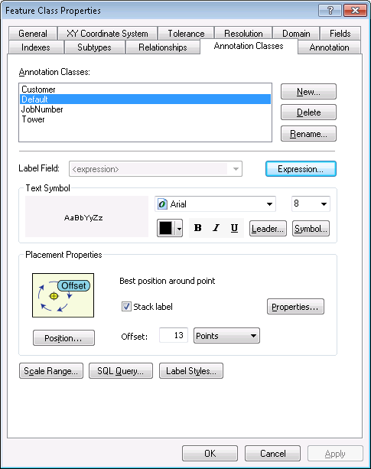

1. Go to **Annotation Classes** Tab
2. Select **Default** from Annotation Classes list and click **Expression** button.
3. Remove the complete text under Expression box.

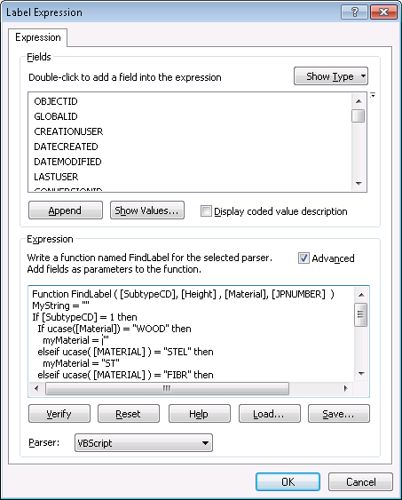

1. Copy the below expression and paste at the same place.

Function FindLabel ( [SubtypeCD], [Height] , [Material], [JPNUMBER] , [GAUGE] )

MyString = ""

If [SubtypeCD] = 1 then

If ucase([Material]) = "WOOD" then

myMaterial = ""

elseif ucase( [MATERIAL] ) = "STEL" then

myMaterial = "ST"

elseif ucase( [MATERIAL] ) = "FIBR" then

myMaterial = "FG"

else

myMaterial = [MATERIAL]

end if

IF myMaterial <> "" THEN

myString = [HEIGHT] +"' " + myMaterial + " "

ELSE

myString = [HEIGHT] +"' "

END IF

elseif [SubtypeCD] = 5 or [SubtypeCD] = 4 or [SubtypeCD] = 2 or [SubtypeCD] = 8 then

MyString = [Height] + "' "

End If

IF [GAUGE] <> "" AND MyString <> "" THEN

IF [GAUGE] = 1 THEN

FindLabel = MyString + "H" + vbCrLf + chr(129)

ELSEIF [GAUGE] = 2 THEN

FindLabel = MyString + "M" + vbCrLf + chr(129)

ELSEIF [GAUGE] = 3 THEN

FindLabel = MyString + "L" + vbCrLf + chr(129)

ELSEIF [GAUGE] = 4 THEN

FindLabel = MyString + "X" + vbCrLf + chr(129)

END IF

ELSEIF [Height] <> 0 THEN

FindLabel = MyString + vbCrLf + chr(129)

END IF

End Function

## Update Spatial Index for DCRectifiers

To implement these steps required exclusive access on the database. No user should be connected to the database.

1. Connect to EDGIS user through ArcCatalog
2. Open EDGIS.ElectricDataSet
3. Open properties for **EDGIS.DCRectifier**
4. Go to **Indexes** tab
5. Click Delete button at **Spatial Index**

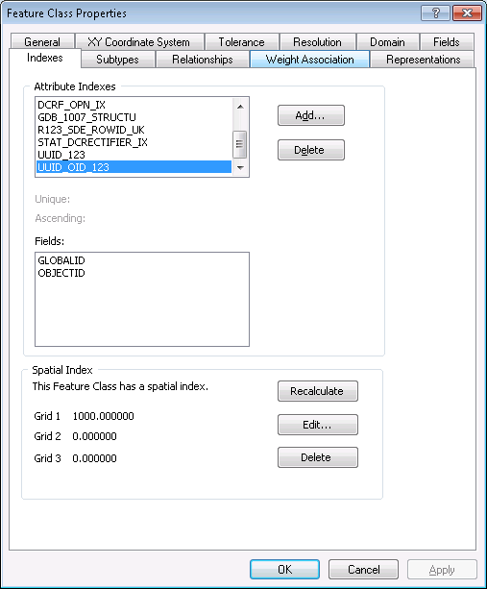

1. Click **Apply**
2. Click **Recalculate**
3. Enter 1000 at **Grid 1:** Textbox as show below. Click **OK**

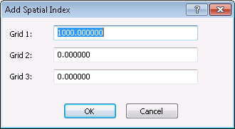

1. Click Apply and OK
2. Repeat same steps for DCRectifierAnno feature class

## Create New Field for Support Structure

To implement these steps required exclusive access on the database. No user should be connected to the database.

1. Navigate to “7.7.3 Scripts” sub-folder.
2. Open **METEREDIDC.py** using **Arcpy IDLE**

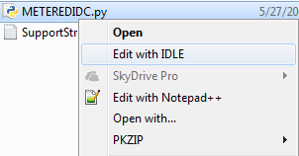

1. Please copy path EDGIS sde connection file path with password save.

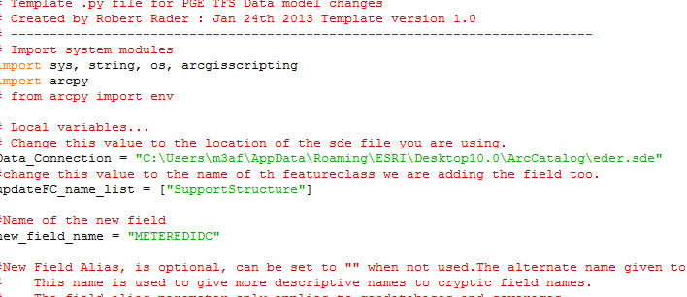

1. Click Save from File Menu
2. Click **Run Module** from Run **Menu**
3. Script should be executed successfully

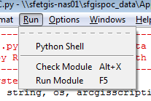

## Update ArcFM properties for SupportStructure

1. Connect to EDGIS thourgh ArcCatalog
2. Open **EDGIS.ElectricDataset**
3. Open ArcFM Properties for **EDGIS.SupportStructure**
4. Go to **Field Info Tab**
5. Select the CEDSAID field from Fields list
6. Change the property **Reset After Create** from **No** to **Yes**

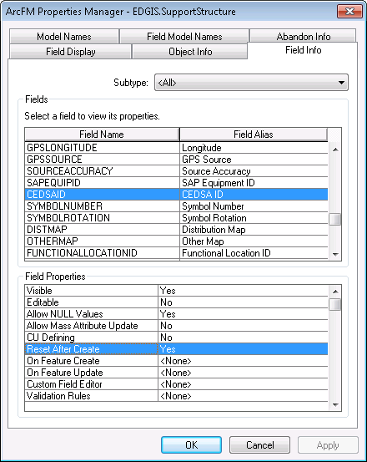

1. Click Apply & OK

## Update ArcFM properties for OpenPoint

1. Connect to EDGIS thourgh ArcCatalog
2. Open **EDGIS.ElectricDataset**
3. Open ArcFM properties for EDGIS.OpenPoint
4. Go to Object Info tab
5. Select **ArcFM Manual Angle Setter** for Create Edit Task property

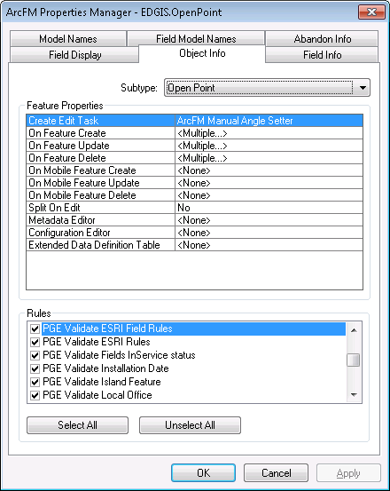

1. Click Apply
2. Go to Field Info Tab
3. Select **SYMBOLRORATION** from field list
4. For **On Create Feature** property select **None** from list

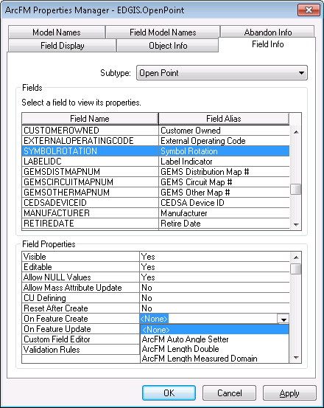

1. Click Apply and OK

## Apply Connectivity Changes

**Important Note**: Prior to making these connectivity changes ensure that you have installed the patch specifically given to PGE from ESRI to address the bug associated with connectivity rule changes not being persisted/applied properly to the geometric network.

* Gain exclusive access to the target environment.
* Open up ArcCatalog and connect to the target environment
* Navigate to the EDGIS.ElectricDataset and select the EDGIS.ElectricDistNetwork geometric network dataset and click Properties.

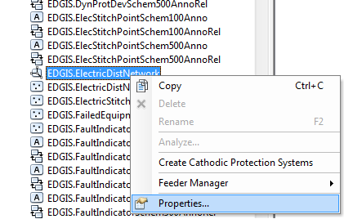

1. Configure the connectivity to allow a connection between an

EDGIS.SecUGConductor (Subtype Single Phase Secondary Underground)

**to a:**

EDGIS.TransformerLead (Subtype TransformerLead)

**via a:**

EDGIS.Transformer (Subtype Distribution OH)

To do this, make the connectivity setting per the following screenshot.

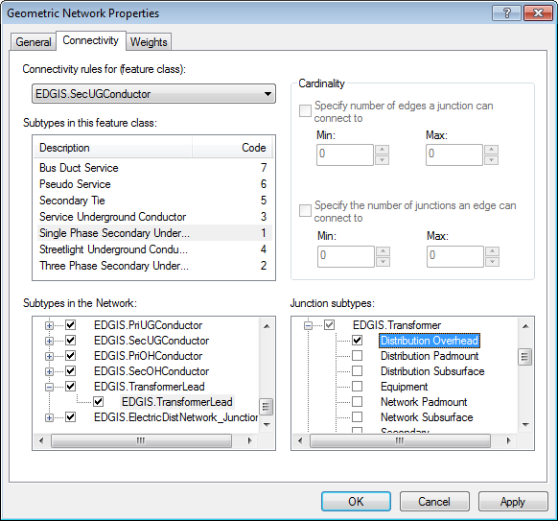

2. Configure the connectivity to allow a connection between an

EDGIS.SecUGConductor (Subtype Pseudo Service)

**to a:**

EDGIS. SecUGConductor (Subtype Single Phase Secondary Underground)

**via a:**

EDGIS.Transformer (Subtype Distribution Subsurface)

To do this, make the connectivity setting per the following screenshot.

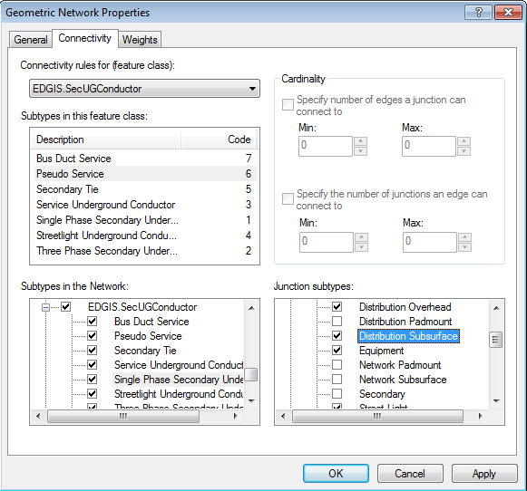

3. Change the cardinality of the following connectivity setting per the screenshot below:

EDGIS.Transformer (Distribution Overhead)

**to a:**

EDGIS. PriOHConductor (TwoPhase Primary Overhead)

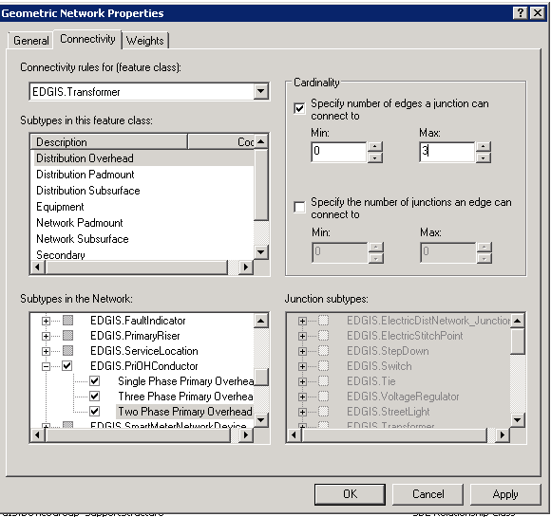

4. Configure the connectivity to allow a connection between an

EDGIS.SecOHConductor (Subtype Single Phase Secondary Overhead)

**to a:**

EDGIS.TransformerLead (Subtype TransformerLead)

**via a:**

EDGIS.Streetlight (Subtype Streetlight)

To do this, make the connectivity setting per the following screenshot.

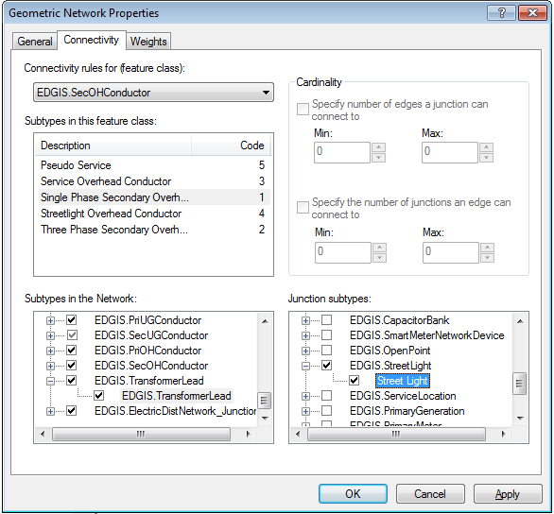

**Important Note**: After changing ANY connectivity settings in the geometric network be sure to perform the following the following steps afterwards to verify that the settings were persisted correctly:

1. Close the Geometric Network Properties form.

2. Navigate to the EDGIS.ElectricDataset again and right click on the EDGIS.ElectricDistNetwork geometric network dataset.

3. Select properties.

4. Verify that the settings that you made in the previous steps involving changes to the geometric network have been actually persisted and that the check boxes indicating that connectivity should be allowed or disallowed are actually checked or unchecked as appropriate. Likewise for changes in connectivity cardinality – verify that Min and Max Settings are correct

## Remove the ‘PGE Validate Closed Device AU’ From Switchable Devices

For the following list of switchable featurelcasses:

* EDGIS.Switch
* EDGIS.Fuse
* EDGIS.DynamicProtectiveDevice
* EDGIS.OpenPoint

Perform the following steps to remove all instances of the ‘PGE Validate Closed Device’ Autoupdater:

1. Open up ArcCatalog
2. Open a connection to the target environment as user: EDGIS
3. Navigate to each switchable featureclass from the list above
4. Right click and select ‘ArcFM Properties Manager’
5. Select the ‘Object Info’ tab
6. Select ‘All’ in the subtype combo box
7. Navigate to the ‘On Feature Create’ in the ‘Feature Properties’ list
8. Click the down arrow to expand out the ‘On Create’ combo list
9. Select the item that says <Multiple…>
10. In the list of Autoupdaters if the item ‘PGE Validate Closed Device’ exists in the list then use select this item as per the screenshot below
11. Click the black left arrow button to remove it from the assigned AUs list on the right
12. Click apply and ok

Repeat step 7 except select the ‘On Feature Update’ event from the ‘Feature Properties’ list

Repeat steps 8 to 12 to remove the AU ‘PGE Validate Closed Device’ from the ‘On Feature Update’ Event.

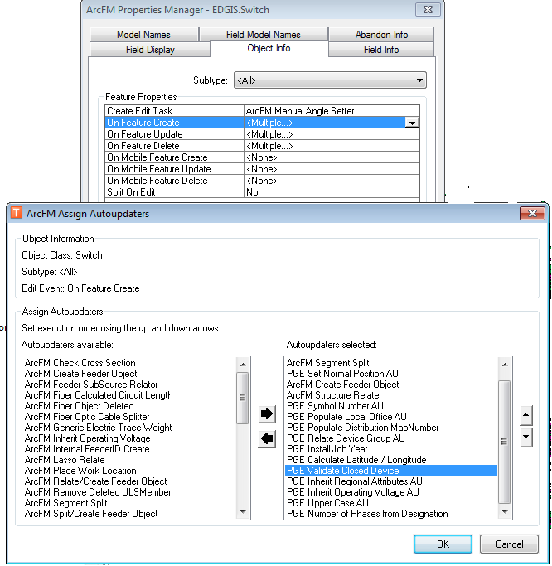

## Rebuild Riser to SupportStructure RelationshipClasses

1. Open up ArcCatalog
2. Connect to the target environment
3. Select the SupportStruct_PriRiser relationshipclass
4. Right Click
5. Select Delete
6. Click Ok to confirm the delete
7. Select the SupportStruct_SecRiser relationshipclass
8. Right Click
9. Select Delete
10. Click Ok to confirm the delete
11. Select the ElectricDataset
12. Right click on the ElectricDataset
13. Select Create New -> Relationship Class
14. Follow the prompts per the following screen shots to re-create the relationship class
15. Repeat steps 11 to 14 to create the SupportStruct_SecRiser relationship class (the only difference is that the dataset name is SupportStruct_SecRiser and the destination featureclass is SecondaryRiser rather than PrimaryRiser. The key field names/cadinality/relationship class type/message propogation etc are exactly the same as for the above instructions for the SupportStruct_PriRiser relationsipclass.

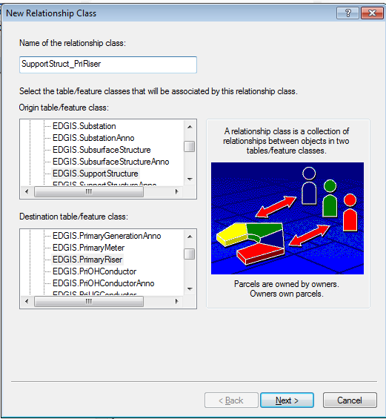

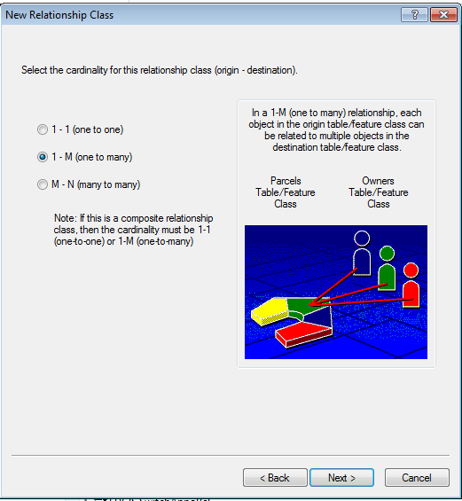

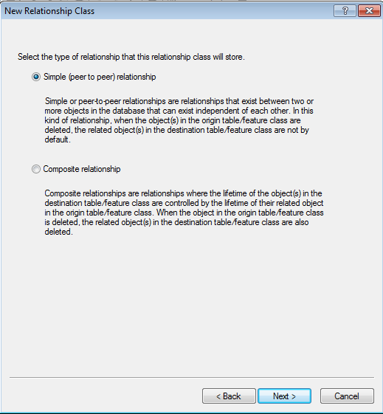

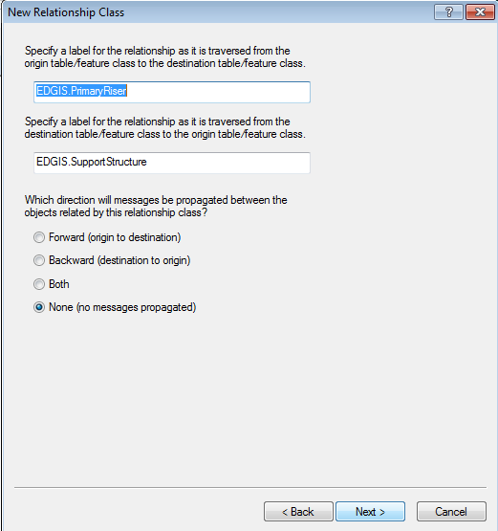

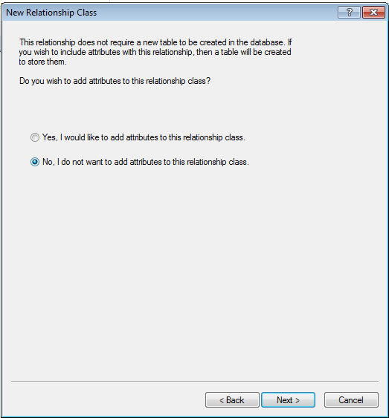

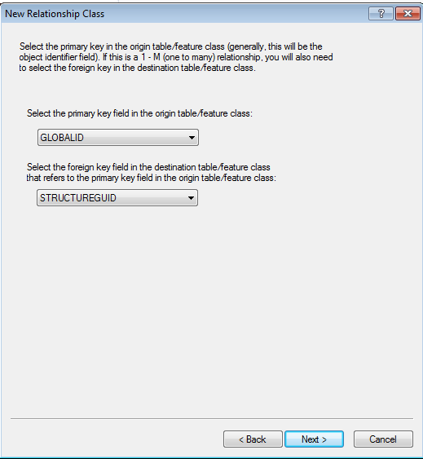

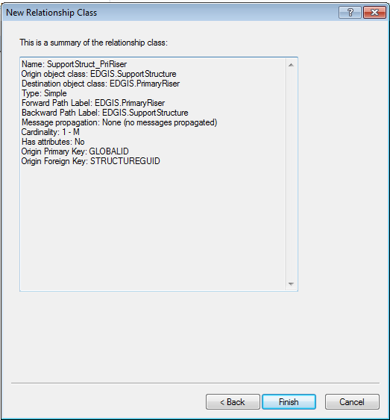

## Rebuild table EDGIS.PGE_SESSION_DELETES_LOG

Recreate the PGE_SESSION_DELETES_LOG table

1. Get exclusive access to the database
2. Open up an ArcCatalog session
3. Connect to the target environment
4. Navigate to the PGE_SESSION_DELETES_LOG table
5. Right Click the PGE_SESSION_DELETES_LOG table and Select Delete
6. Click yes at the prompt to confirm the delete of the table
7. Close the ArcCatalog connection to the target environment
8. Open up a TOAD session
9. Connect to the desired target as user EDGIS
10. Navigate to the PGE_SESSION_DELETES_LOG table and Right Click and Select Delete
11. Create a table called EDGIS.PGE_SESSION_DELETES_LOG in the target environment by running the following SQL statement:

CREATE TABLE EDGIS.PGE_SESSION_DELETES_LOG

(

OBJECTID INTEGER NOT NULL,

USER_NAME NVARCHAR2(32),

DATE_TIME DATE,

SESSION_ID INTEGER,

VERSION_NAME NVARCHAR2(80),

SESSION_DEL_COUNT INTEGER,

DATASET_DEL_COUNT INTEGER,

DATASET_NAME NVARCHAR2(60));

Commit;

Re-populate the PGE_SESSION_DELETES_LOG table

1. Get exclusive access to the database
2. Open up a TOAD session
3. Connect to the desired target as user EDGIS
4. Run the following statements to populate the table data

Insert into EDGIS.PGE_SESSION_DELETES_LOG

(OBJECTID, USER_NAME, DATE_TIME, SESSION_ID, VERSION_NAME,

SESSION_DEL_COUNT)

Values

(961, 'S1GE', TO_DATE('04/09/2014 12:20:35', 'MM/DD/YYYY HH24:MI:SS'), 34758, 'K4SN.SN_34758',

2);

Insert into EDGIS.PGE_SESSION_DELETES_LOG

(OBJECTID, USER_NAME, DATE_TIME, SESSION_ID, VERSION_NAME,

SESSION_DEL_COUNT)

Values

(321, 'PNRH', TO_DATE('02/26/2014 17:23:58', 'MM/DD/YYYY HH24:MI:SS'), 25919, 'PNRH.SN_25919',

861);

Insert into EDGIS.PGE_SESSION_DELETES_LOG

(OBJECTID, USER_NAME, DATE_TIME, SESSION_ID, VERSION_NAME,

SESSION_DEL_COUNT)

Values

(322, 'PNRH', TO_DATE('02/26/2014 17:35:39', 'MM/DD/YYYY HH24:MI:SS'), 25969, 'PNRH.SN_25969',

508);

Insert into EDGIS.PGE_SESSION_DELETES_LOG

(OBJECTID, USER_NAME, DATE_TIME, SESSION_ID, VERSION_NAME,

SESSION_DEL_COUNT)

Values

(323, 'PNRH', TO_DATE('02/26/2014 17:43:06', 'MM/DD/YYYY HH24:MI:SS'), 25971, 'PNRH.SN_25971',

604);

Insert into EDGIS.PGE_SESSION_DELETES_LOG

(OBJECTID, USER_NAME, DATE_TIME, SESSION_ID, VERSION_NAME,

SESSION_DEL_COUNT)

Values

(643, 'VBP3', TO_DATE('04/01/2014 09:27:00', 'MM/DD/YYYY HH24:MI:SS'), 32653, 'TEMPEDITOR.SN_32653',

4894);

Insert into EDGIS.PGE_SESSION_DELETES_LOG

(OBJECTID, USER_NAME, DATE_TIME, SESSION_ID, VERSION_NAME,

SESSION_DEL_COUNT)

Values

(1, 'PNRH', TO_DATE('02/26/2014 16:59:14', 'MM/DD/YYYY HH24:MI:SS'), 25959, 'PNRH.SN_25959',

599);

Insert into EDGIS.PGE_SESSION_DELETES_LOG

(OBJECTID, USER_NAME, DATE_TIME, SESSION_ID, VERSION_NAME,

SESSION_DEL_COUNT)

Values

(641, 'P1P4', TO_DATE('03/31/2014 16:09:33', 'MM/DD/YYYY HH24:MI:SS'), 32653, 'TEMPEDITOR.SN_32653',

4894);

Insert into EDGIS.PGE_SESSION_DELETES_LOG

(OBJECTID, USER_NAME, DATE_TIME, SESSION_ID, VERSION_NAME,

SESSION_DEL_COUNT)

Values

(642, 'P1P4', TO_DATE('03/31/2014 17:16:37', 'MM/DD/YYYY HH24:MI:SS'), 32653, 'TEMPEDITOR.SN_32653',

4894);

COMMIT;

Grant Permisssions for PGE_SESSION_DELETES_LOG table / Register with Geodatabase

1. Get exclusive access to the database
2. Open up an ArcCatalog session
3. Connect to the target environment
4. Navigate to the PGE_SESSION_DELETES_LOG table
5. Right click on the dataset and select Priveleges
6. Grant view permission to user: SDE_VIEWER
7. Grant edit permission to user: SDE_EDITOR
8. Navigate to the new table EDGIS.PGE_SESSION_DELETES_LOG again
9. Right click the mouse
10. Select register with the geodatabase (DO NOT Register as Versioned – **this table should NOT be versioned**)

Assign the Object Model Name to this table called: PGE_SESSION_DELETES_LOG by following the following steps:

1. Ensure that you still have exclusive access to the database
2. Open up ArcCatalog
3. Open up your connection to the target environment (user should be EDGIS)
4. Right click on the EDGIS.PGE_SESSION_DELETES_LOG object and click ArcFM Properties Manager
5. Select the Model Names tab
6. In the left hand list box find the PGE_SESSION_DELETES_LOG model name that you created
7. Click on the Arrow button pointing to the right to apply the new model name to the EDGIS. PGE_SESSION_DELETES_LOG table
8. Click OK

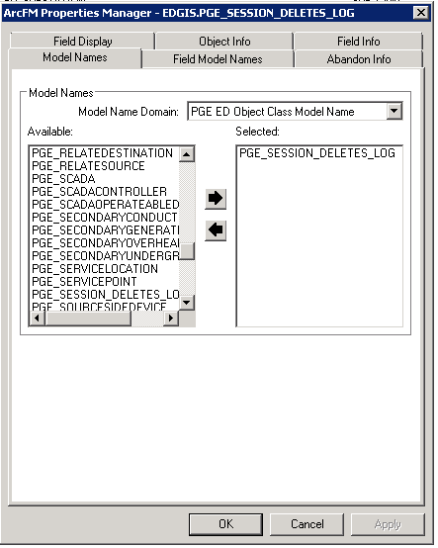

# Original Release 7.8.1

## 16714 - Apply these field properties for Fuse

1. Open ArcCatalog
2. Create a connection to the database to change as the user EDGIS
3. Expand the ElectricDataset
4. Select the “**Fuse**” featureclass
5. Right Click and choose “ArcFM Properties”
6. Choose the “Field Info” Tab
7. Make sure the subtype is set to "ALL"
8. Set Visibility= Yes
9. Make sure the subtype is set to "Overhead"
10. Set Visibility= Yes
11. Make sure the subtype is set to "Underground"
12. Set Visibility= Yes

## 17193 - ArcFM Field properties on Voltage Regulator (ArcFM FP 1.5)

1. Open up ArcCatalog
2. Connect as user: SDE
3. Right click on the connection in ArcCatalog and select ‘Versions…’
4. In the Version Manager select the SDE.Default version row
5. Right click on the row and select “Properties…”

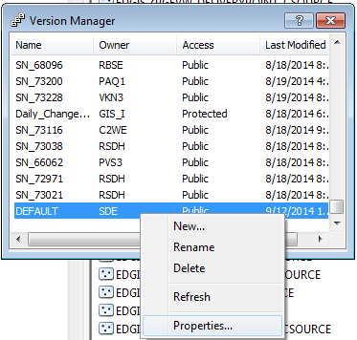

1. Change the permission from ‘Protected’ to ‘Public’ by selecting the corresponding radio button on the dialog
2. Click Apply and Ok.
3. Close the ArcCatalog connection.
4. Open up another ArcCatalog connection.
5. Connect as user: EDGIS
6. Take a backup of ArcFM properties for Voltage Regulator & Volatage Regulator Unit

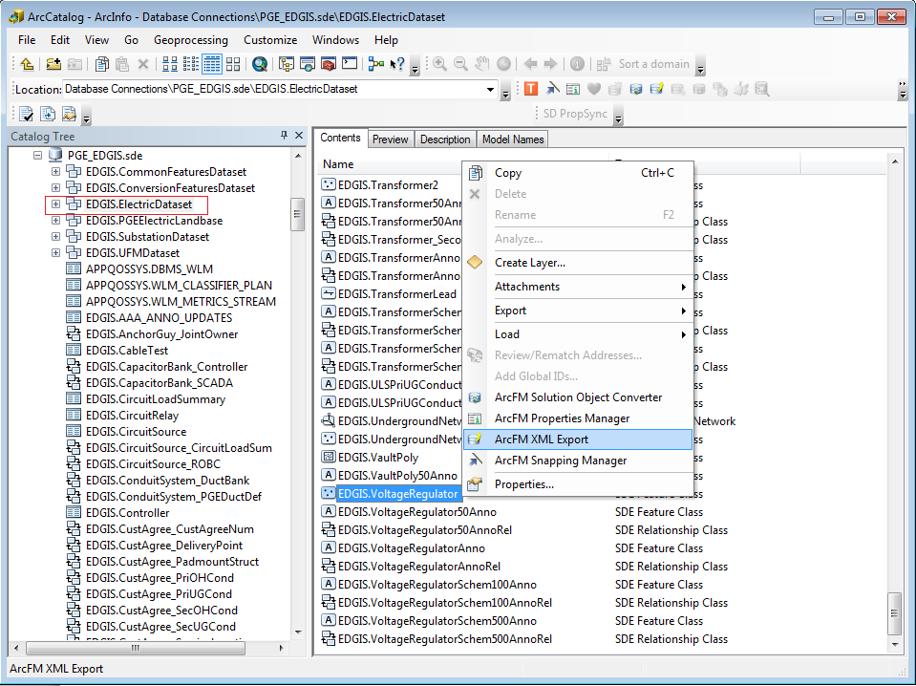

1. Right click on the connection and select “**ArcFM XML Import”**

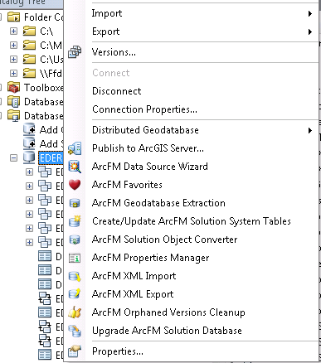

1. Be sure that the ‘**Overwrite’** option button is selected

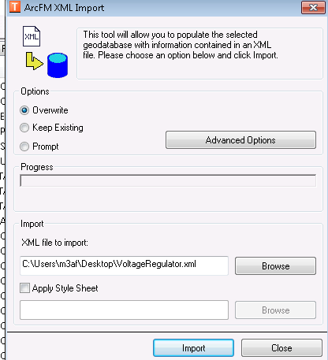

1. Select ArcFM xml file (**VoltageRegulator_QA.xml**) from the “**ArcFM EDER Field Properties**” sub folder.
2. Click “**Import**”.
3. You will get successful message as below.Click “No”.

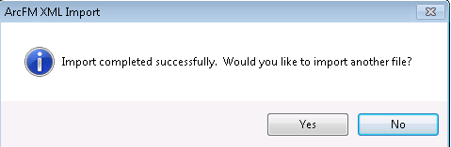

1. Open “**ArcFM Properties Manager**” for **EDGIS.VoltageRegulatorUnit**

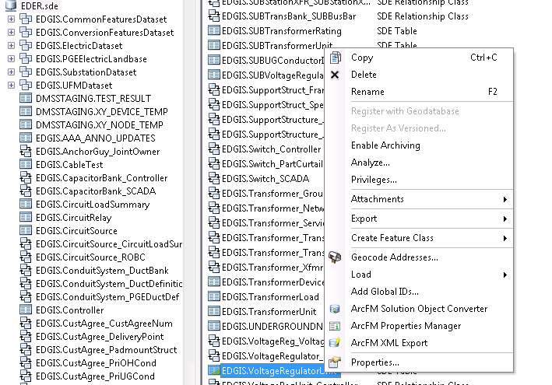

1. Go to Field Info tab
2. Select **Voltage Regulator Unit** in Subtype dropdown

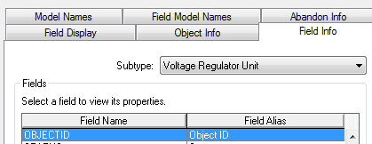

1. Select **STATUS** field
2. Set **Allow NULL Values** to **No**
3. Click **Apply**

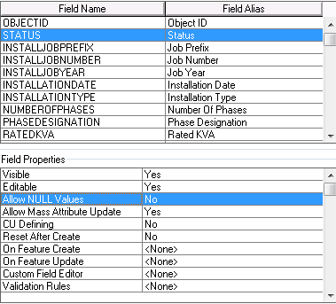

1. Select **INSTALLJOBYEAR** field
2. Set **Allow NULL Values** to **Yes**
3. Click **Apply**

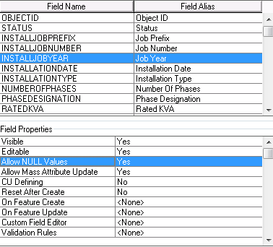

1. Select **CREATIONUSER** field
2. Select **ArcFM Login User Name** AU on On Feature Create
3. Click **Apply**

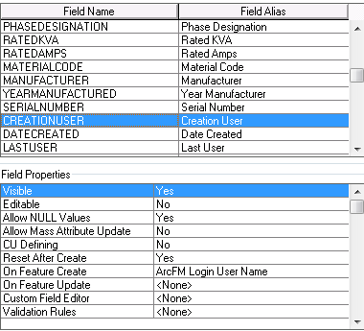

1. Select **DATECREATED** field
2. Select **ArcFM Current Date** AU on On Feature Create
3. Click **Apply**

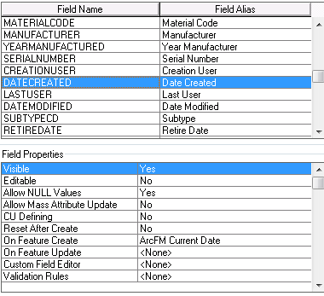

1. Select **LASTUSER** field
2. Select **ArcFM Login User Name** AU on On Feature Update
3. Click **Apply**

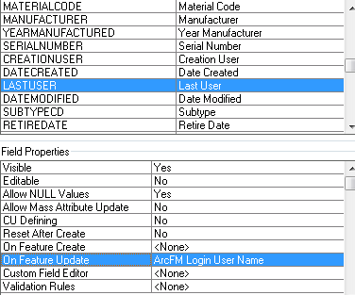

1. Select **DATEMODIFIED** field
2. Select **ArcFM Current Date** AU on On Feature Update

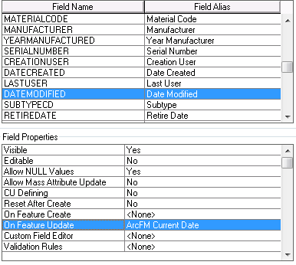

1. Click **Apply** and **OK**

# Original Release 7.8.2

## Create PGE Field Level Model Names

1. Right click on the database connection and select properties
2. Select the **Domains** tab
3. Select the item in the Domain Name column that says ‘**PGE ED Field Model Name**’
4. Add the following two model names

* Code: PGE_AUTOBOOSTER Description: PGE_AUTOBOOSTER
* Code: PGE_STRUCTURESIZE Description: PGE_STRUCTURESIZE

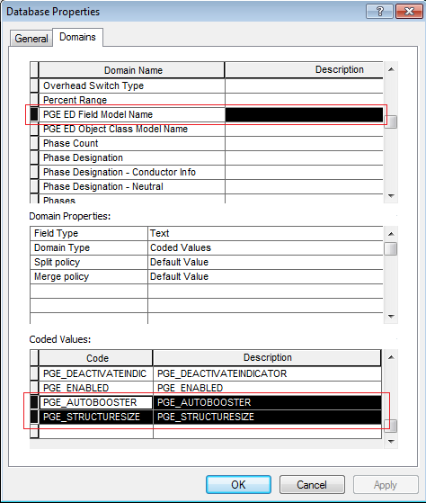

1. Click Apply. Click OK.

## Create Table Level Model Names

1. Right click on the database connection and select properties
2. Select the **Domains** tab
3. Select the item in the Domain Name column that says ‘**PGE ED Object Class Model Name**’
4. Add the following model name:

Code: ESRI_SPLITWITHUPDATE Description: ESRI_SPLITWITHUPDATE

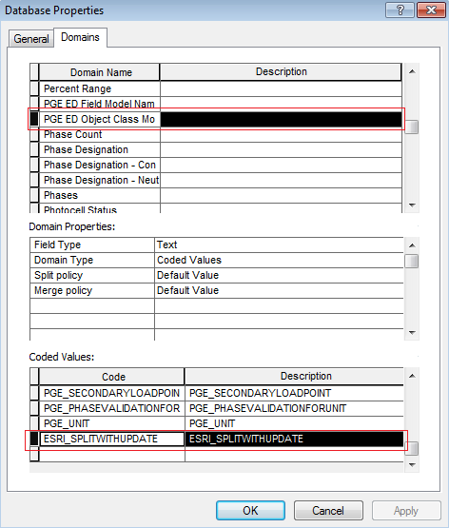

1. Click Apply. Click OK.

## Update the ‘Tenant Name’ Domain

**Verify that:**

1. The database connection referenced in the python script (TenantName.py) in “Scripts” folderis **the** **database** **you are going to update** and exists in your ArcCatalog ‘Database Connections’ folder. Modify the database connection in the python script in notepad if required.
2. The user for the connection is **EDGIS**
3. The connection is able to actually connect to the database (test this by double clicking the connection in ArcCatalog)

**To run the script:**

1. Navigate to the **“Scripts”** folder in the install directory
2. Copy the script **TenantName.py** to your local drive
3. Right click the script and select Edit With Idle
4. Click F5 to run the script
5. Verify that no errors are received

Note: You will see a number of entries that say:

This code: value does not exist – but this is not an error and can be ignored.

## Update Annotation Expression for StreetLightAnno

1. In the ElectricDataset, navigate to the **StreetlightAnno** feature class
2. Right click and select “Properties…”
3. Select the **Annotation Classes** tab
4. Select the **Default** Annotation Class
5. Click on the **Expression**… button
6. Copy the following entire annotation expression to the clip board

Function FindLabel ( [Ownership], [StreetLightNumber] )

streetlightNum = ""

If [StreetLightNumber] <> "0" then

streetlightNum = [StreetLightNumber]

End If

If [Ownership]<> "Company" then

FindLabel = streetlightNum & vbCrLf & "C"

else

FindLabel = streetlightNum

End if

End Function

1. In the expression text box delete the entire existing annotation expression
2. Then click **Ctrl+V** to paste the previously copied expression
3. Click Verify
4. Upon successful verification Click Ok
5. Click Apply and OK in the Featureclass Properties form for StreetLightAnno
6. Repeat all steps for **EDGIS.StreetLight50Anno.**

## Update Annotation Expression for SupportStructureAnno

1. In the ElectricDataset, navigate to the **SupportStructureAnno** feature class
2. Right click and select properties
3. Select the Annotation Classes tab
4. Select the **Default** Annotation Class
5. Click on the Expression… button
6. Copy the following entire annotation expression to the clip board

Function FindLabel ( [SubtypeCD], [Height] , [Material], [JPNUMBER] , [GAUGE] )

MyString = ""

If [SubtypeCD] = 1 or [SubtypeCD] = 4 then

If ucase([Material]) = "WOOD" then

myMaterial = ""

elseif ucase( [MATERIAL] ) = "STEL" then

myMaterial = "ST"

elseif ucase( [MATERIAL] ) = "FIBR" then

myMaterial = "FG"

else

myMaterial = [MATERIAL]

end if

IF myMaterial <> "" THEN

myString = [HEIGHT] +"' " + myMaterial + " "

ELSE

myString = [HEIGHT] +"' "

END IF

elseif [SubtypeCD] = 5 or [SubtypeCD] = 2 or [SubtypeCD] = 8 then

MyString = [Height] + "' "

End If

IF [GAUGE] <> "" AND MyString <> "" THEN

IF [GAUGE] = 1 THEN

FindLabel = MyString + "H" + vbCrLf + chr(129)

ELSEIF [GAUGE] = 2 THEN

FindLabel = MyString + "M" + vbCrLf + chr(129)

ELSEIF [GAUGE] = 3 THEN

FindLabel = MyString + "L" + vbCrLf + chr(129)

ELSEIF [GAUGE] = 4 THEN

FindLabel = MyString + "X" + vbCrLf + chr(129)

END IF

ELSEIF [Height] <> 0 THEN

FindLabel = MyString + vbCrLf + chr(129)

END IF

End Function

1. In the expression text box delete the entire existing annotation expression
2. Then click Ctrl+V to paste the previously copied expression
3. Click Verify
4. Upon successful verification Click Ok
5. Click Apply and Ok in the Featureclass Properties form for SupportStructureAnno
6. Repeat all steps for **EDGIS.SupportStructure50Anno**.

## Update DynamicProtectiveDeviceAnno

Remove the ‘CCRating’ Annotation class:

1. In the ElectricDataset, navigate to the **DynamicProtectiveDeviceAnno** featureclass
2. Right click and select properties
3. Select the Annotation Classes tab
4. Select the ‘**CCRating’** Annotation Class
5. Click on the Delete button to remove this annotation class completely
6. Click Apply and Ok
7. Repeat all steps for **EDGIS.DynProtDevice50Anno**.

Update the ‘**Default’** annotation expression:

1. Navigate to the **DynamicProtectiveDeviceAnno** featureclass
2. Right click and select properties
3. Select the Annotation Classes tab
4. Select the **Default** Annotation Class
5. Click on the Expression… button
6. Copy the following entire annotation expression to the clip board

Function FindLabel ( [SubtypeCD] ,[OperatingNumber], [MULTIFUNCTIONALIDC] , [SwitchModeIdc])

switchSuffix = ""

if [SwitchModeIdc]= "Yes" and [SubtypeCD] = "Interrupter" then

switchSuffix = "-SM"

elseif [SubtypeCD] = "Recloser" and [MULTIFUNCTIONALIDC] = "Yes" then

switchSuffix = "-MF"

End if

FindLabel = [OperatingNumber] & switchSuffix

End Function

1. In the expression text box delete the entire existing annotation expression
2. Then click Ctrl-V to paste the previously copied expression
3. Click Verify
4. Upon successful verification Click Ok
5. Click Apply and Ok in the Featureclass Properties form for DynamicProtectiveDeviceAnno
6. Repeat all steps for **EDGIS.DynProtDevice50Anno**.

## Add the DuctCount field for EDGIS.PGEDuctDefinition (INC000003866881)

1. In the root, navigate to ‘**EDGIS.PGEDuctDefinition**’ table



1. Right click and click on “Properties...”
2. Navigate to “**Fields**” tab and add the **DuctCount** field with below properties.



1. Click on Apply button
2. Navigate to “**Subtypes”** tab
3. Select Code 1 – **Duct Bank** and navigate to Field name-DuctCount then enter 1 in default value and select domain – ‘Range Domain 1-99’



1. Click on Apply.
2. Select Code 2 – **Conduit**
3. Navigate to Field name-DuctCount
4. Enter 1 in default value and select domain – ‘Range Domain 1-99’
5. Click on Apply and Ok button.
6. **Please make sure that Default Subtype value should be conduit in subtype tab.**

## Add the ‘IS - Innovative Switchgear Solutions Inc’ value in Device Manufacture Domain(INC000003885629)

1. In the ElectricDataset, navigate to EDGIS.Switch
2. Right click on the feature class and select “Properties…”

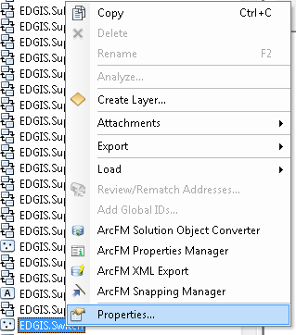

1. Go to Subtype tab and click on domains button at bottom.

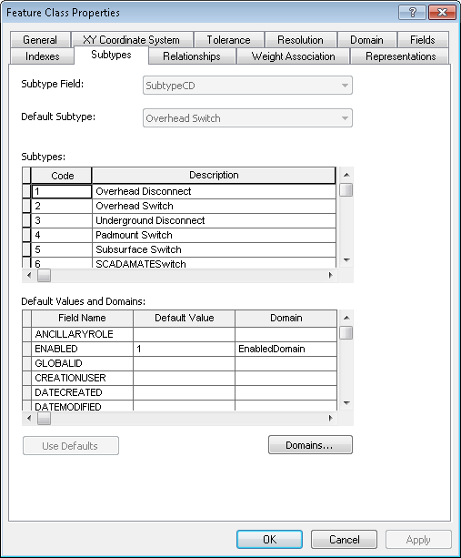

1. Select the ‘Device Manufacturer’ from Domains List

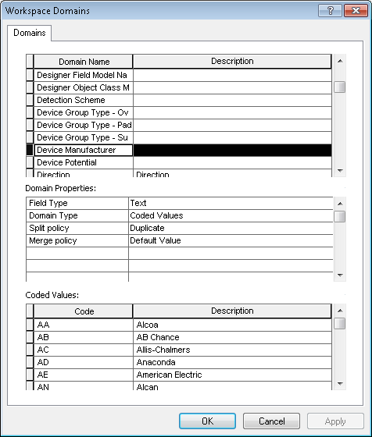

1. Add the ‘IS - Innovative Switchgear Solutions Inc’ value and click on apply and OK button

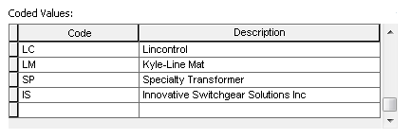

1. In ArcCatalog right click anywhere on the main toolbar and select Customize…
2. Select the commands tab
3. Click on the ‘Add from File’ button
4. Browse and select the DomainSort.dll that is in the ‘Sort_a_domain\Visual_Basic’ directory of the release folder
5. From the 'Developer Samples' commands category, add the 'DomainSortCmd' command to an existing toolbar or the context menu for a geodatabase.
6. Use ArcCatalog to browse to the EDER database to sort a domain from.
7. Click on the command to bring up the dialog, and make choose below parameters for the sort.

Available Domains: - Device Manufacture

Sort Type: - Ascending

Sort Item:- Description

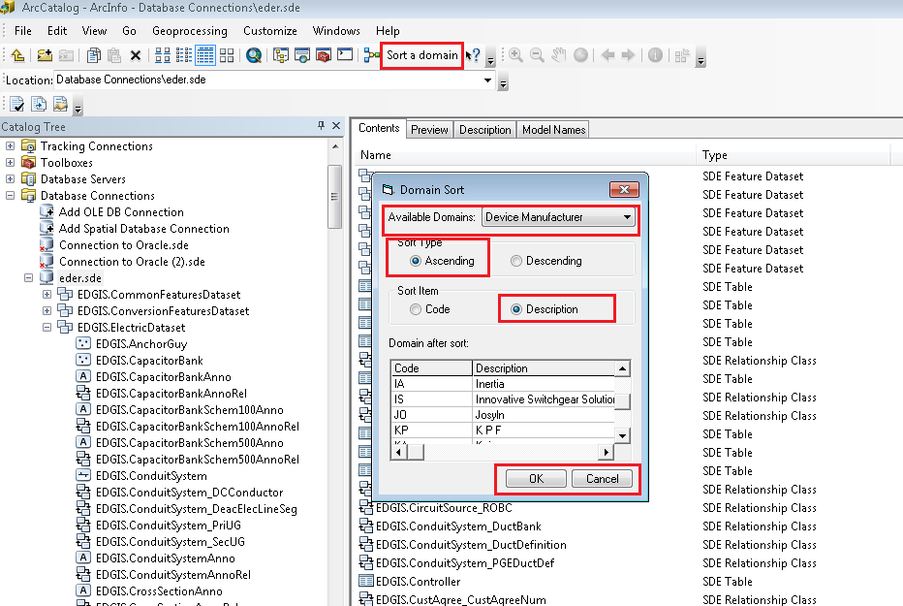

1. Click on Ok.

Copy Domain.XML file that is in the ‘ED50’ directory of the release folder and paste/replace into ED50 installation folder where Domain.XML file is already exit in all Production/QA Servers.

## Apply Symbol Number Configuration to Switch Feature Class

1. Open ArcMap
2. Login to the target environment via the ArcFM login dialog.
3. Connect as user: EDGIS
4. Launch the *Rule Definition Editor* (a.k.a. - ***Symbol Number Config***). If not present on one of the toolbars, open the *Customize* dialog, click on the *Commands* tab and click on *PGE Admin Tools*. The *Symbol Number Config* command can be found in the list. Simply drag to a location on one of the ArcMap toolbars.
5. Select FeatureDataset : EDGIS. Electric Dataset and Feature Class: EDGIS.Switch from the combo boxes.
6. Open the file called Switch Symbol.xml located in the SymbolNumberXML folder in the release folder.
7. Copy the entire contents of the file to the clipboard
8. Select In the validation Rule Defintion text box and click Ctrl-A (to select all) and paste the copied content
9. Click the Validate button to perform validation on the xml document
10. If successful, click the Save button
11. Close the Rule Definition Editor window

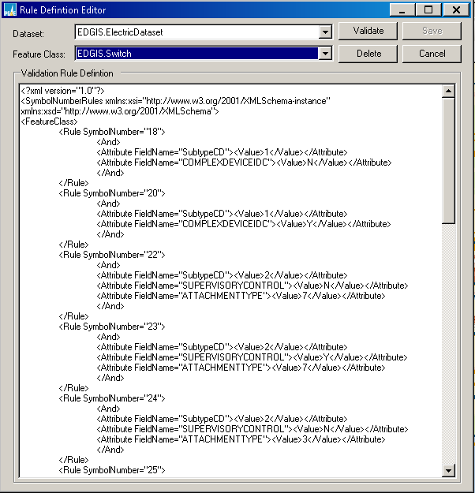

## Apply Symbol Number Configuration to Capacitor bank Feature Class

1. Open ArcMap
2. Login to the target environment via the ArcFM login dialog.
3. Connect as user: EDGIS
4. Launch the *Rule Definition Editor* (a.k.a. - ***Symbol Number Config***). If not present on one of the toolbars, open the *Customize* dialog, click on the *Commands* tab and click on *PGE Admin Tools*. The *Symbol Number Config* command can be found in the list. Simply drag to a location on one of the ArcMap toolbars.
5. Select FeatureDataset : EDGIS. Electric Dataset and Feature Class: EDGIS.CapacitorBank from the combo boxes.
6. Open the file called CapacitorBank.xml located in the SymbolNumberXML folder in the release folder.
7. Copy the entire contents of the file to the clipboard
8. Select In the validation Rule Defintion text box and click Ctrl-A (to select all) and paste the copied content
9. Click the Validate button to perform validation on the xml document
10. If successful, click the Save button
11. Close the Rule Definition Editor window

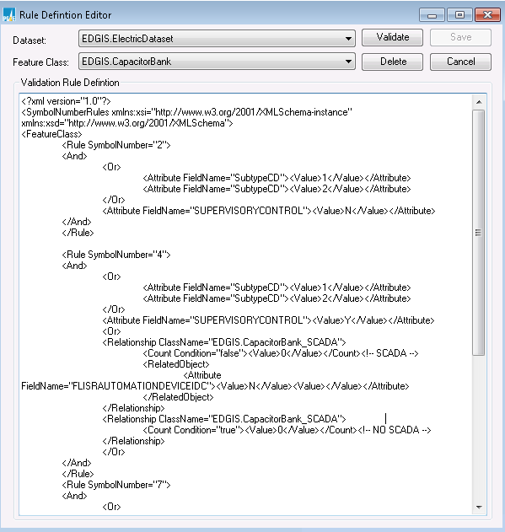

## Update EDGIS.SubTransformerUnit table Configuration (INC000003926560)

1. Gain exclusive access to the environment
2. Open ArcCatlog
3. Connect to EDGIS database as EDGIS User
4. In the root, navigate to **EDGIS.SubTransformerUnit** table.
5. Right click and click on properties.
6. Navigate to field tab and add the below fields
7. **Connection code (CONNECTIONCODE)**

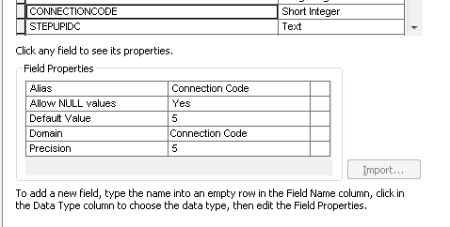

1. Click Apply button.
2. **ZHL % Imp (ZHLPCTIMP)**



1. Click Apply button.
2. **Boost Percent (BOOSTPERCENT)**

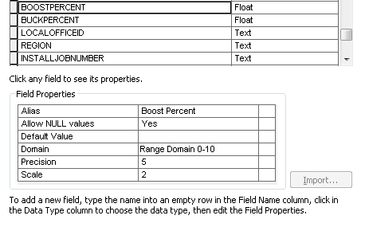

1. Click Apply button.
2. **Buck Percent (BUCKPERCENT)**

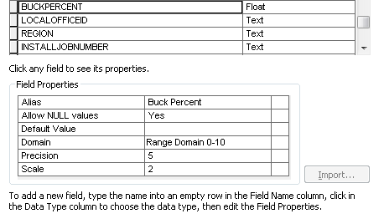

1. Click Apply button.
2. **ZH % IMP (ZHPCTIMP)**



1. Click Apply button.
2. **ZL % IMP (ZLPCTIMP)**



1. Click Apply button.
2. **ZT % IMP (ZTPCTIMP)**



1. Click Apply button.
2. **ZGB % Imp (ZGBPCTIMP)**



1. Click Apply button.
2. Click on Subtype tab and go to default values and Domains then apply the below domains and default value to field names.



1. Click on Apply and ok button.

## Create new Domain and new Field for Primary Generation Feature Class

1. Right click the database and select “Properties…”
2. Select the Domains tab
3. Create New Domain with following information

**Domain Name** - PrimaryGenerationCapacitySize

**Type** - Text

**Domain Type** - Coded Values

**Domain Value** – KW, MW

1) Enter Domain Name

2) Select Field Type to Text

3) Enter Code & Value as show below

4) Click **Apply & OK**

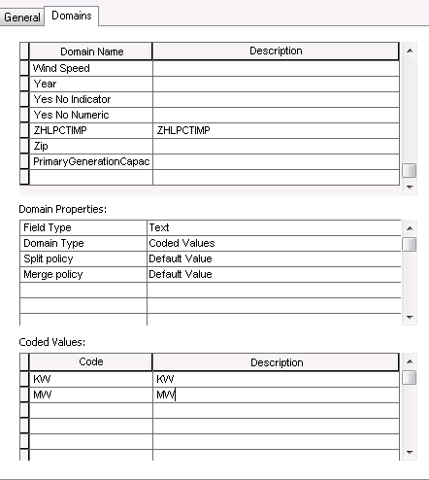

**Step 3**

**Step 2**

**Step 1**

1. In the ElectricDataset, navigate to the **EDGIS.PrimaryGeneration** feature class
2. Create a new field with below information.

**Field name** - CapacitySize

**Alais Name** - Capacity Size

**Type** - Text

**Domain** - PrimaryGenerationCapacitySize

**Length** – 2

1) Open Properties of EDGIS.PrimaryGeneration

2) Go to Fields Tab

3) Enter Field Name CAPACITYSIZE and select Datatype Text

4) Enter the Alias Name Capacity Size

5) Select the domain PrimaryGenerationCapacitySize

6) Click Apply & OK



1. Update Annotation Expresion for **EDGIS.PrimaryGenerationAnno**
2. Open Feature class properties for EDGIS.PrimaryGenerationAnno
3. Go to Annotation Classes Tab
4. Select **Default** click on **Expression…** 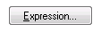
5. In the expression text box delete the entire existing annotation expression.
6. Copy the below text and paste

Function FindLabel ([SubtypeCD], [Capacity], [NameOfCoGenerator],[CapacitySize] )

If [SubtypeCD] = "CoGeneration" Or [SubtypeCD] = "Primary Generation" then

IF ISNULL([CapacitySize]) THEN

FindLabel = [NameOfCoGenerator] & vbCrLf & [Capacity]

ELSE

IF ISNULL([Capacity]) THEN

FindLabel = [NameOfCoGenerator] & vbCrLf & [Capacity]

ELSE

FindLabel = [NameOfCoGenerator] & vbCrLf & [Capacity] & " " & [CapacitySize]

END IF

END IF

END IF

End Function

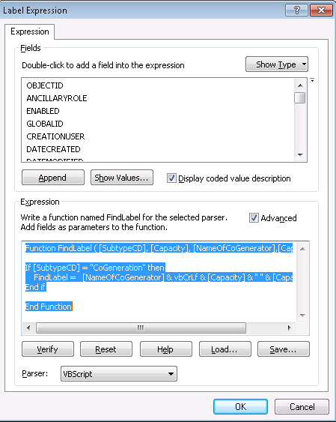

1. Click OK

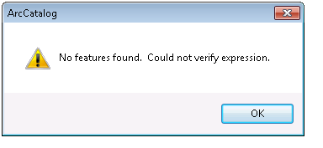

1. Click Apply and OK on Properties dialog

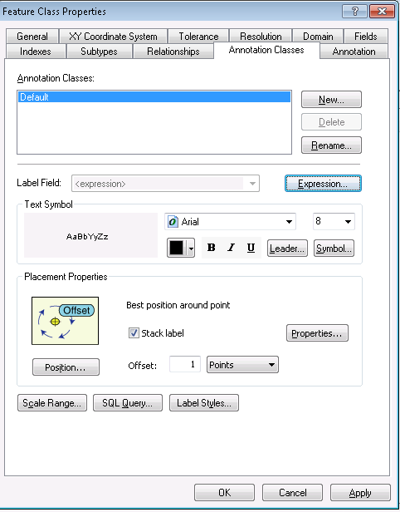

1. Repeat step 6 for **EDGIS.PrimaryGeneration50Anno**

## Apply ArcFM XML Configuration

Each of these items will involve the importing of an ArcFM XML Configuration file. The general steps for the importing of each of these files is:

1. Open up ArcCatalog
2. Connect as user: SDE
3. Right click on the connection in ArcCatalog and select ‘Versions…’
4. In the Version Manager select the SDE.Default version row
5. Right click on the row and select “Properties…”



1. Change the permission from ‘Protected’ to ‘Public’ by selecting the corresponding radio button on the dialog
2. Click Apply and Ok.
3. Close the ArcCatalog connection.
4. Open up another ArcCatalog connection.
5. Connect as user: EDGIS
6. Right click on the connection and select **ArcFM XML Import**
7. Be sure that the ‘**Overwrite’** option button is selected
8. Navigate to each ArcFM xml file
9. Select Import

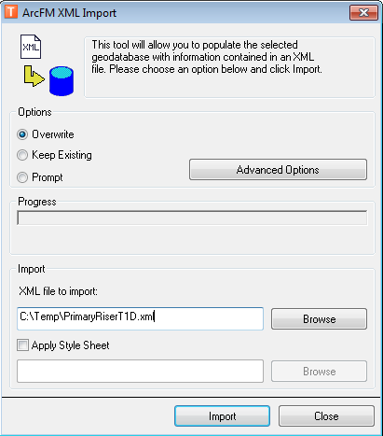

Using the general steps above to load all of the xml files that are in the “**Config**” directory of the document release folder:

* EDGIS.AnchorGuy.xml
* EDGIS.CircuitRelay.xml
* EDGIS.CircuitSource.xml
* EDGIS.ConduitSystem.xml
* EDGIS.Controller.xml
* EDGIS.DeactivatedElectricLineSegment.xml
* EDGIS.FaultIndicator.xml
* EDGIS.GroundingBank.xml
* EDGIS.Inverter.xml
* EDGIS.JointOwner.xml
* EDGIS.LoadCheckPoint.xml
* EDGIS.NetworkProtector.xml
* EDGIS.NeutralConductor.xml
* EDGIS.PGEDuctDefinition.xml
* EDGIS.PhotoVolaticCell.xml
* EDGIS.PrimaryGeneration.xml
* EDGIS.PrimaryMeter.xml
* EDGIS.PrimaryRiser.xml
* EDGIS.ProtectiveDevice.xml
* EDGIS.RelayControl.xml
* EDGIS.RemoteTermUnit.xml
* EDGIS.SCADA.xml
* EDGIS.SecondaryRiser.xml
* EDGIS.SecUGConductor.xml
* EDGIS.ServicePoint.xml
* EDGIS.SpanGuy.xml
* EDGIS.StepDownUnit.xml
* EDGIS.SubsurfaceStructure.xml
* EDGIS.SUBTransformerUnit.xml
* EDGIS.Transformer.xml
* EDGIS.TransformerDevice.xml
* EDGIS.TransformerLead.xml
* EDGIS.VaultPoly.xml
* EDGIS.VoltageRegulator.xml

After completing the xml import follow these steps to reset the protection level of SDE Default back to ‘Protected’

1. Open up ArcCatalog
2. Connect as user: SDE
3. Right click on the connection in ArcCatalog and select ‘Versions…’
4. In the Version Manager select the SDE.Default version row
5. Right click on the row and select “Properties…”
6. Change the permission from ‘Public’ back to ‘Protected’ by selecting the corresponding radio button on the dialog
7. Click Apply and Ok

## Check JointOwner Configuration

Follow the steps below to check that the model name ‘LOCATABLEFIELD’ has been applied to the ObjectId and JONAME fields on the JointOwner featureclass.

Note: There should be no actual changes required for this step – this is just a check.

1. Open up an ArcCatalog session
2. Connect as user EDGIS
3. Navigate to the EDGIS.JointOwner table



1. Right Click and select ArcFM Properties Manager
2. Navigate to the Field Model Names Tab
3. Select the ObjectID and the JONAME field and verify that these field have the LOCATABLEFIELD model name applied to them as per the screen shots below. If not applied, assign LOCATABLEFIELD model name to the respective field.

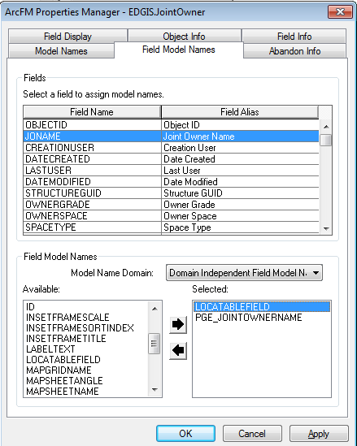

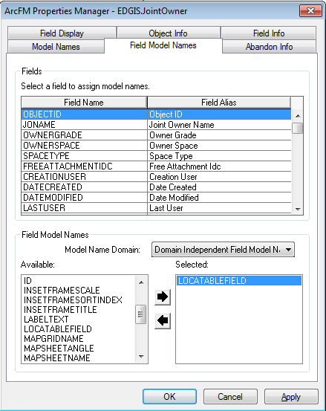

## Change PrimaryRiser Default Value for InstallJobNumber

1. In the ElectricDataset, navigate to the PrimaryRiser featureclass
2. Right click and select “Properties…”
3. Select the fields tab
4. Scroll down and select the INSTALLJOBNUMBER field
5. Set the Default Value for this field to 0 (per the screen shot below)
6. Click Apply and Ok

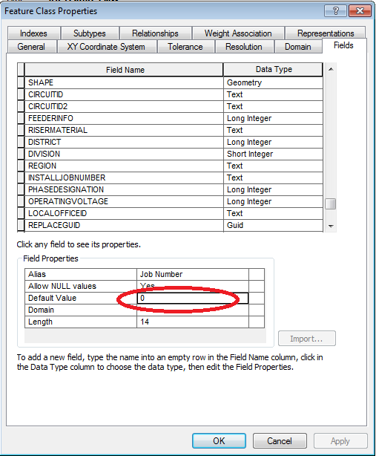

## Change Streetlight OWNERSHIP Field to Visible

1. Gain exclusive to the target environment
2. Open up an ArcCatalog session
3. Connect as user EDGIS
4. In the ElectricDataset, navigate to the EDGIS.Streetlight featureclass
5. Right Click and select ArcFM Properties Manager
6. Select the Field Info tab
7. Scroll down to the OWNERSHIP field
8. Set the Visible property to YES
9. Select Apply and Ok

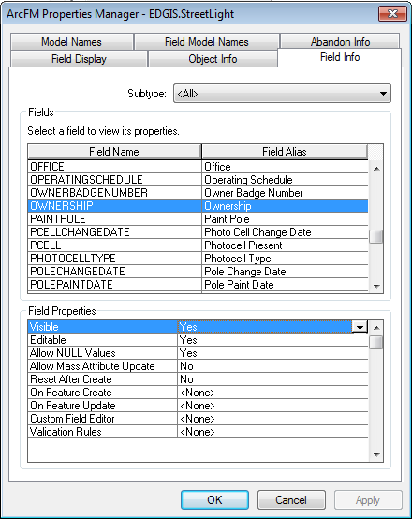

## Apply Connectivity Changes

**Important Note:** Verify that the QIP ESRI Patch has been installed on the machine that you are using to make these connectivity changes. Without this patch there is no guarantee that these settings will be implemented correctly.

* Gain exclusive access to the target environment.
* Open up ArcCatalog and connect to the target environment
* Navigate to the EDGIS.ElectricDataset and select the EDGIS.ElectricDistNetwork geometric network dataset and click Properties.



1. Configure the connectivity to allow a connection between an

EDGIS.PriUGConductor (Subtype Single Phase Primary Underground)

**to a:**

EDGIS.DistBusBar (Subtype Pri Dist Bus Bar)

**via a:**

Fuse subtype: Underground

To do this, perform the connectivity setting per the screenshot below, then click Apply and Ok.

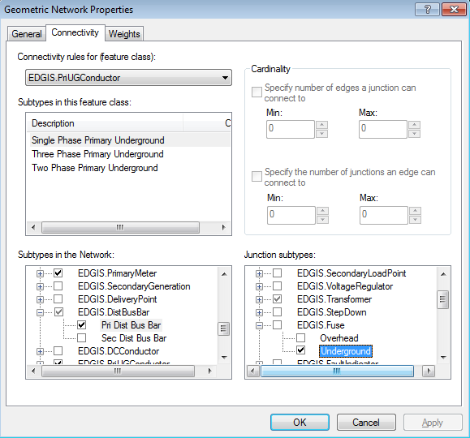

2. Configure the connectivity to allow a connection between an

EDGIS.PriOHConductor (Subtype Two Phase Primary Overhead)

**to a:**

EDGIS. PriOHConductor (Subtype Two Phase Primary Overhead)

**via a:**

EDGIS.OpenPoint (Subtype Conductor Change)

To do this, perform the connectivity setting per the screenshot below, then click Apply and Ok.

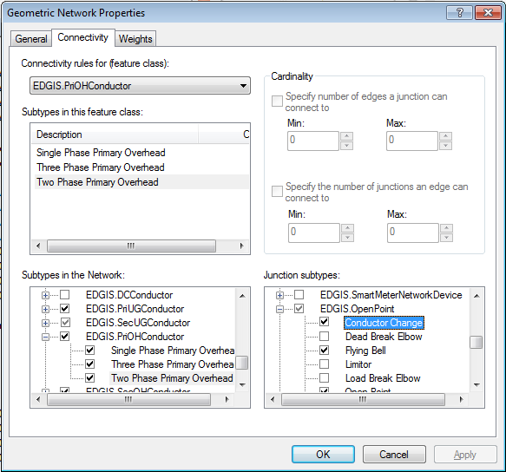

3. Configure the connectivity to allow a connection between a

EDGIS.TransformerLead (Subtype Transformer Lead)

**to a:**

EDGIS.SecUGConductor (Subtype Service Underground Conductor)

**via a:**

EDGIS.Transformer (Subtype Distribution Overhead)

To do this, perform the connectivity setting per the screenshot below, then click Apply and Ok.

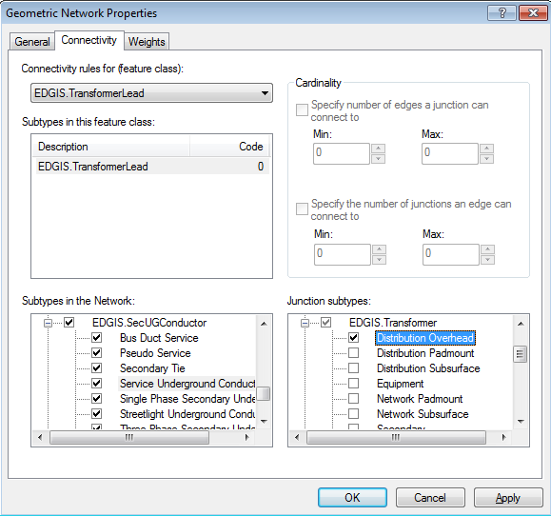

4. Configure the connectivity to allow a connection between a

EDGIS.SecOHConductor (Subtype Pseudo Service)

**to a:**

EDGIS.TransformerLead (Subtype Transformer Lead)

**via a:**

EDGIS.StreetLight (Subtype StreetLight)

To do this, perform the connectivity setting per the screenshot below, then click Apply and Ok.

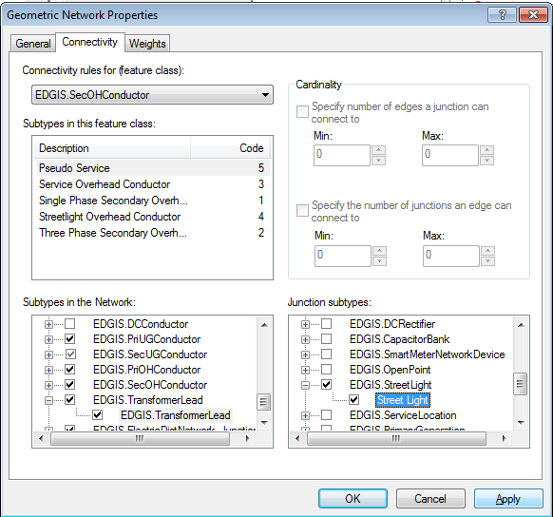

5. Configure the connectivity to allow a connection between a

EDGIS.SecOHConductor (Subtype Pseudo Service)

**to a:**

EDGIS.SecOHConductor (Subtype Pseudo Service)

**via a:**

EDGIS.StreetLight (Subtype StreetLight)

To do this, perform the connectivity setting per the screenshot below, then click Apply and Ok.

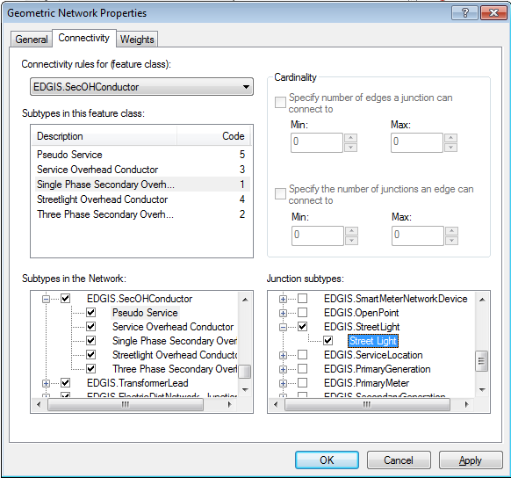

6. Re-configure the connectivity to allow the following EDGE to JUNCTION connection between:

EDGIS.PriOHConductor (Subtype Two Phase Primary Overhead)

**to a:**

EDGIS.OpenPoint (Subtype Conductor Change)

**Note: this is slightly different to the usual steps for EDGE to EDGE connectivity rules**

To do this, perform the following steps:

1) Right Click the Geometric Network and Select Properties (as previously)

2) Select PriOHConductor – Subtype Two Phase Primary Overhead

3) In the ‘Subtypes in the Network’ lower treeview on the form, **REMOVE** the tick in the box against OpenPoint Subtype: Conductor Change

4) Click Apply and Ok

5) Right Click the Geometric Network and Select Properties

6) Select PriOHConductor – Subtype Two Phase Primary Overhead

7) In the ‘Subtypes in the Network’ **ADD** the tick in the box against OpenPoint Subtype: Conductor Change

8) Click Apply and Ok

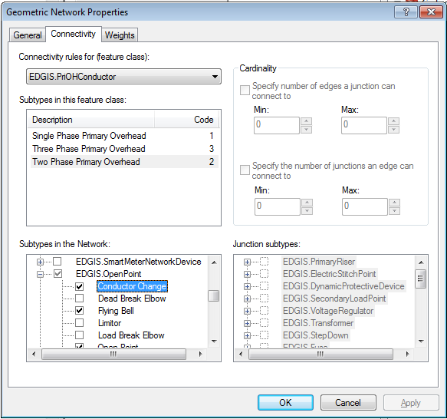

# Original Release 7.8.3

## 17473 - Data Model 7.8.3 - Bayonet Fuses on 2500kva padmount transformers

**Verify that:**

1. The database connection referenced in all the python scripts in “7.8.3 Scripts” folder is **the** **database** **you are going to update** and exists in your ArcCatalog ‘Database Connections’ folder. Modify the database connection in the python script in notepad if required.
2. The user for the connection is **EDGIS**
3. The connection is able to actually connect to the database (test this by double clicking the connection in ArcCatalog)

**To run the script:**

1. Navigate to the “**7.8.3 Scripts**” folder in the install directory
2. Copy all the scripts to your local drive
3. Right click on **trans_unit_short_desc_remove.py** and select “Edit With Idle”
4. Click F5 to run the script
5. Verify that no errors are received

Note: You may see a number of entries that say: “ERROR 000192: Invalid value for Code Value” – but this can be ignored (for **trans_unit_short_desc_remove.py** only**).**

**Following the above instructions run (follow the sequence):**

1. trans_unit_short_desc_add.py
2. trans_unit_type_overhead_remove.py
3. trans_unit_type_overhead_add.py
4. trans_unit_type_subsurface_remove.py
5. trans_unit_type_subsurface_add.py
6. trans_unit_type_surface_remove.py
7. trans_unit_type_surface_add.py

# Original Release 7.8.4

## 17833 - DA issue: Create organization boundaries columns

Add following fields on following feature classes:

**EDGIS.PrimaryRiser**

1. In the Electric Dataset, locate the “EDGIS.PrimaryRiser” feature class. Right click and select “Properties…”
2. In “Fields” tab, scroll to the bottom and add the following fields:

a) City (alias City)

Data Type: text

Length: 40

**Field Model: PGE_CITY, PGE_Inheritcity**

1. In the Electric Dataset, locate the “EDGIS.PrimaryRiser” feature class. Right click and select “ArcFM Properties Manager”
2. Go to Field Model Names tab. Select City field. Assign PGE_CITY, PGE_Inheritcity field model names to it.

b) County (alias County)

Data Type: short Integer

Length: 5

Domain: County Name

**Field Model: PGE_County, PGE_Inheritcounty**

1. In the Electric Dataset, locate the “EDGIS.PrimaryRiser” feature class. Right click and select “ArcFM Properties Manager”
2. Go to Field Model Names tab. Select County field. Assign PGE_County, PGE_Inheritcounty field model names to it.

c) Zip (alias Zip Code)

Data Type: text

Length: 10

**Field Model: PGE_ZIP, PGE_InheritZIP**

1. In the Electric Dataset, locate the “EDGIS.PrimaryRiser” feature class. Right click and select “ArcFM Properties Manager”
2. Go to Field Model Names tab. Select Zip field. AssignPGE_ZIP, PGE_InheritZIP field model names to it.

**EDGIS.AnchorGuy**

1. In the Electric Dataset, locate the “EDGIS. AnchorGuy” feature class. Right click and select “Properties…”
2. In “Fields” tab, scroll to the bottom and add the following fields.

a) City (alias City)

Data Type: text

Length: 40

**Field Model: PGE_CITY, PGE_Inheritcity**

1. In the Electric Dataset, locate the “EDGIS.AnchorGuy” feature class. Right click and select “ArcFM Properties Manager”
2. Go to Field Model Names tab. Select City field. Assign PGE_CITY, PGE_Inheritcity field model names to it.

b) County (alias County)

Data Type: short Integer

Length: 5

Domain: County Name

**Field Model: PGE_County, PGE_Inheritcounty**

1. In the Electric Dataset, locate the “EDGIS.AnchorGuy” feature class. Right click and select “ArcFM Properties Manager”
2. Go to Field Model Names tab. Select County field. Assign PGE_County, PGE_Inheritcounty field model names to it.

c) Zip (alias Zip Code)

Data Type: text

Length: 10

**Field Model: PGE_ZIP, PGE_InheritZIP**

1. In the Electric Dataset, locate the “EDGIS.AnchorGuy” feature class. Right click and select “ArcFM Properties Manager”
2. Go to Field Model Names tab. Select Zip field. Assign PGE_ZIP, PGE_InheritZIP field model names to it.

**EDGIS.VaultPoly**

1. In the Electric Dataset, locate the “EDGIS. VaultPoly” feature class. Right click and select “Properties…”
2. In “Fields” tab, scroll to the bottom and add the following fields.

a) City (alias City)

Data Type: text

Length: 40

**Field Model: PGE_CITY, PGE_Inheritcity**

1. In the Electric Dataset, locate the “EDGIS. VaultPoly” feature class. Right click and select “ArcFM Properties Manager”
2. Go to Field Model Names tab. Select City field. Assign PGE_CITY, PGE_Inheritcity field model names to it.

b) County (alias County)

Data Type: short Integer

Length: 5

Domain: County Name

**Field Model: PGE_County, PGE_Inheritcounty**

1. In the Electric Dataset, locate the “EDGIS. VaultPoly” feature class. Right click and select “ArcFM Properties Manager”
2. Go to Field Model Names tab. Select County field. Assign PGE_County, PGE_Inheritcounty field model names to it.

c) Zip (alias Zip Code)

Data Type: text

Length: 10

**Field Model: PGE_ZIP, PGE_InheritZIP**

1. In the Electric Dataset, locate the “EDGIS. VaultPoly” feature class. Right click and select “ArcFM Properties Manager”
2. Go to Field Model Names tab. Select Zip field. Assign PGE_ZIP, PGE_InheritZIP field model names to it.

**EDGIS.DeactivatedElectricLineSegment**

1. In the Electric Dataset, locate the “EDGIS. DeactivatedElectricLineSegment” feature class. Right click and select “Properties…”
2. In “Fields” tab, scroll to the bottom and add the following fields.

a) City (alias City)

Data Type: text

Length: 40

**Field Model: PGE_CITY, PGE_Inheritcity**

1. In the Electric Dataset, locate the “EDGIS. DeactivatedElectricLineSegment” feature class. Right click and select “ArcFM Properties Manager”
2. Go to Field Model Names tab. Select City field. Assign PGE_CITY, PGE_Inheritcity field model names to it.

b) County (alias County)

Data Type: short Integer

Length: 5

Domain: County Name

**Field Model: PGE_County, PGE_Inheritcounty**

1. In the Electric Dataset, locate the “EDGIS. DeactivatedElectricLineSegment” feature class. Right click and select “ArcFM Properties Manager”
2. Go to Field Model Names tab. Select County field. Assign PGE_County, PGE_Inheritcounty field model names to it.

c) Zip (alias Zip Code)

Data Type: text

Length: 10

**Field Model: PGE_ZIP, PGE_InheritZIP**

1. In the Electric Dataset, locate the “EDGIS. DeactivatedElectricLineSegment” feature class. Right click and select “ArcFM Properties Manager”
2. Go to Field Model Names tab. Select Zip field. Assign PGE_ZIP, PGE_InheritZIP field model names to it.

**EDGIS.SecondaryRiser**

1. In the Electric Dataset, locate the “EDGIS. SecondaryRiser” feature class. Right click and select “Properties…”
2. In “Fields” tab, scroll to the bottom and add the following fields.

a) City (alias City)

Data Type: text

Length: 40

**Field Model: PGE_CITY, PGE_Inheritcity**

1. In the Electric Dataset, locate the “EDGIS. SecondaryRiser” feature class. Right click and select “ArcFM Properties Manager”
2. Go to Field Model Names tab. Select City field. Assign PGE_CITY, PGE_Inheritcity field model names to it.

b) County (alias County)

Data Type: short Integer

Length: 5

Domain: County Name

**Field Model: PGE_County, PGE_Inheritcounty**

1. In the Electric Dataset, locate the “EDGIS. SecondaryRiser” feature class. Right click and select “ArcFM Properties Manager”
2. Go to Field Model Names tab. Select County field. Assign PGE_County, PGE_Inheritcounty field model names to it.

c) Zip (alias Zip Code)

Data Type: text

Length: 10

**Field Model: PGE_ZIP, PGE_InheritZIP**

1. In the Electric Dataset, locate the “EDGIS. SecondaryRiser” feature class. Right click and select “ArcFM Properties Manager”
2. Go to Field Model Names tab. Select Zip field. Assign PGE_ZIP, PGE_InheritZIP field model names to it.

**List of Feature Classes:**

1. EDGIS.PrimaryRiser
2. EDGIS.SecondaryRiser
3. EDGIS.DeactivatedElectricLineSegment
4. EDGIS.VaultPoly
5. EDGIS.AnchorGuy

**Verify Field Model names (Assign field model names if not present for all the listed Feature Classes)**

Go to “Field Model Names” tab in ArcFM Properties Manager.

a) Field: **Region** (alias Service Area)

Field Model Name:

PGE_Inheritregion

PGE_ASSETCOPY

 b) Field: **Division** (alias Division)

Field Model Name:

PGE_Division

PGE_InheritDivision

PGE_Locator_Division

c) Field: **District** (alias District)

Field Model Name:

PGE_DISTRICT

PGE_InheritDistrict

**Assign ArcFM Model Name to all the listed Feature Classes:**

Go to “Model Names” tab in ArcFM Properties Manager.

PGE_Validateregionalattributes

PGE _enforce_region

**Assign AU on object class level to all the listed Feature Classes:**

Go to “Object Info” tab in ArcFM Properties Manager.

**On Feature Create**:  PGE inherit regional attributes AU

**On Feature Update**: PGE inherit regional attributes AU

## 17836 - DA Issue: ArcFM Field Properties updates for Transformer

1. Gain exclusive access to the environment
2. Open ArcCatlog
3. Connect to EDGIS database as EDGIS user
4. Navigate to ‘**EDGIS.Transformer**’ Feature Class
5. Right click and click on “Properties…”
6. Navigate to “Subtypes” tab
7. Please make sure that Default Subtype value is ‘Distribution Overhead’.
8. Click on the Row which has Code/Description: “1” / “Distribution Overhead” in SubTypes:

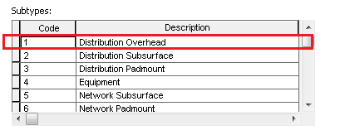

1. Navigate to ‘INSTALLATIONTYPE’ field and apply the below default value ‘OH’.

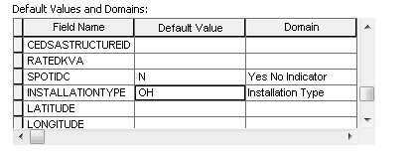

1. Click on Apply and OK button

**Apply the ArcFM properties to ‘Transformer’:**

* Open up ArcCatalog
* Connect as EDGIS
* Navigate to **EDGIS. Transformer**
* Select “ArcFM Properties Manager”
* Navigate to the Field Info Tab
* Select the **<ALL>** in subtypes combo
* Navigate to ‘*INSTALLATIONTYPE*’ Field and change the ‘Allow NULL Values’ Field Properties to ‘No’ -as in the screen shot below.

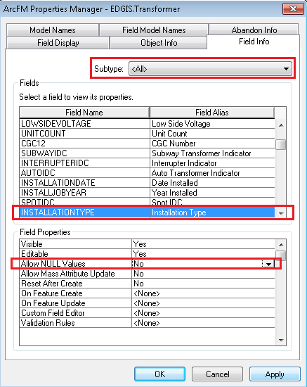

## 18010 - Configure Controller table to send DEVICEGUID with ED50

1. Log in to desired database in ArcCatalog as edgis
2. Right click on the **EDGIS.Controller** table and choose "ArcFM Properties Manager"
3. Click on the Field Model Names tab.
4. Scroll down to the "DEVICEGUID" field and select it.
5. Select the "PGE ED Field Model Name" domain from the drop down.
6. Select the "**PGE_DMSFIELD**" from the list of available model names.
7. Click OK.

# Original Release 7.8.5

## Add the NominalVoltage field for EDGIS.PriOHConductor and EDGIS.PriUGConductor

1. Gain exclusive access to the environment
2. Open arcCatlog
3. Connect to EDGIS database as EDGIS user
4. Navigate to ‘EDGIS.PriOHConductor’ Feature Class.
5. Right click and click on properties.
6. Navigate to field tab and add the ‘NominalVoltage’ field with below properties.

Field Name – NominalVoltage

Alias Name - Nominal Voltage

Type – Long Integer

Precision – 10

Default Value – NULL (**Not need to enter anything**)

Domain - Primary Voltage

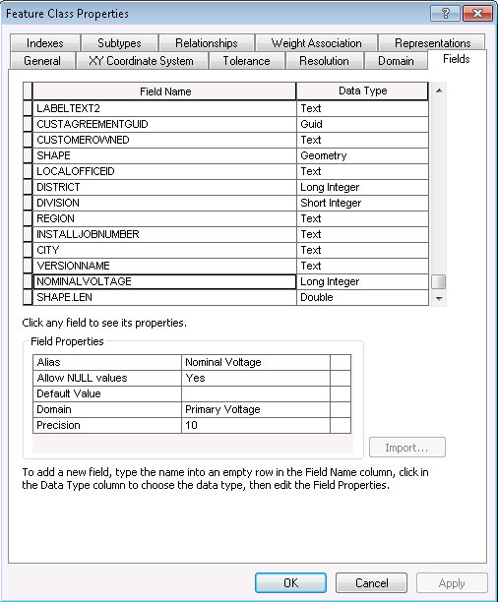

1. Click on Apply Button.
2. **Repeat the step from 3 to 7 on “EDGIS.PriUGConductor”.**

## Apply ArcFM properties for EDGIS.PriOHConductor and EDGIS.PriUGConductor

1. Open up ArcCatalog
2. Navigate to the ‘EDGIS.PriOHConductor’.
3. Right click and select ArcFM properties Manger
4. Navigate to Field Info tab.
5. Select <All> in SubType drop down List.
6. Navigate to ‘Nominal Voltage’ Field.
7. Apply the below field properties.

Visible – Yes

Editable - No

Allow NULL Values – Yes

Allow Mass Attribute Update – No

Reset After Create - No

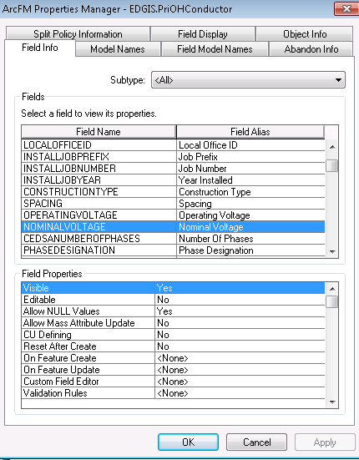

1. Click on Apply.
2. Navigate to Field Model Names tab
3. Navigate to ‘NominalVolatge’ Field.
4. Assign the ‘PGE_ASSETCOPY’ model name.

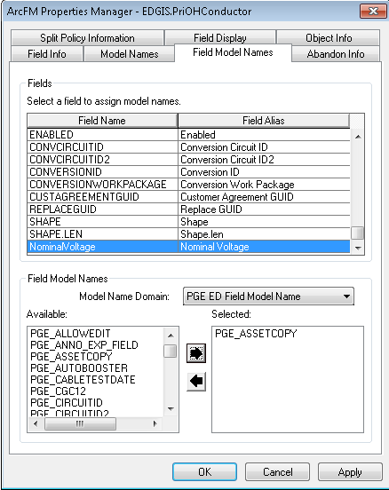

1. Click on Apply and Ok Button.
2. Navigate to “EDGIS.PriUGConductor”.
3. **Repeat the steps from 4 to 13 on “EDGIS.PriUGConductor”.**

## Update ArcFM Field Display order for EDGIS.PriOHConductor and EDGIS.PriUGConductor

1. Open up ArcCatalog
2. Navigate to the ‘EDGIS.PriOHConductor’.
3. Right click and select ArcFM properties Manger
4. Navigate to Field Display tab
5. Select the ‘Nominal voltage’ and rearrange it (Put after the operating Voltage)

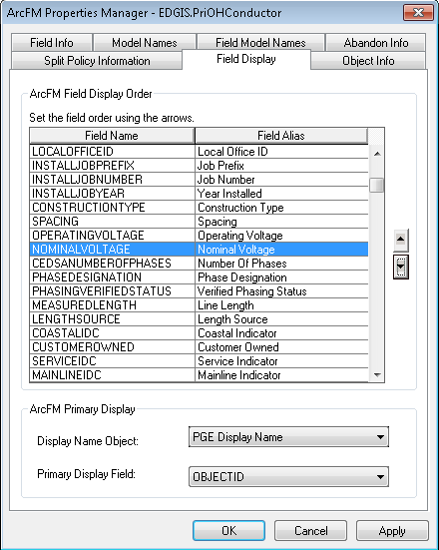

1. Click on Apply and Ok Button.
2. Navigate to ‘EDGIS.PriUGConductor’.
3. **Repeat the steps from 3 to 6 on ‘EDGIS.PriUGConductor’.**

## Apply PGE Inherit Nominal Voltage AU

1. Open ArcFM Properties for EDGIS.PriOHConductor
2. Go to Object Info tab
3. For **On Feature Create, Click <Multiple…> and Select Multiple**

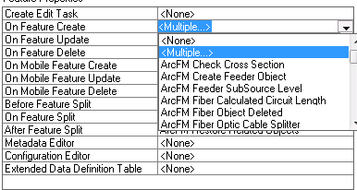

1. Move PGE Inherit Nominal Voltage AU to Right side and move up as show in the below figure

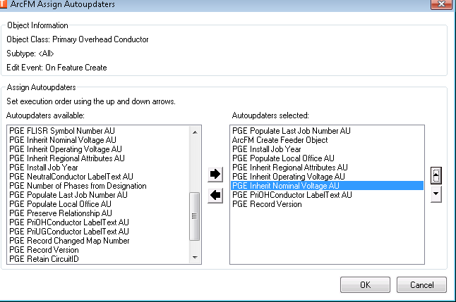

1. Click Apply & OK
2. Apply same AU On Feature Update

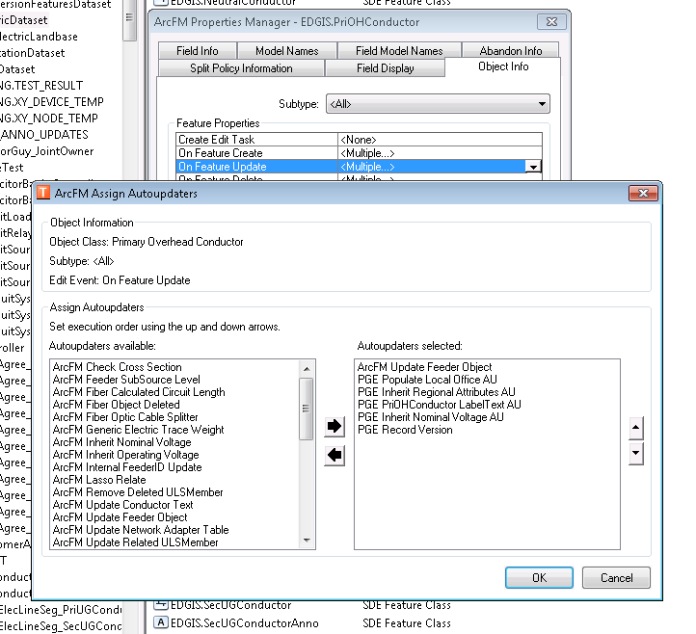

**Apply the same change to EDGIS.PriUGConductor. Follow the step from 1 to 5.**

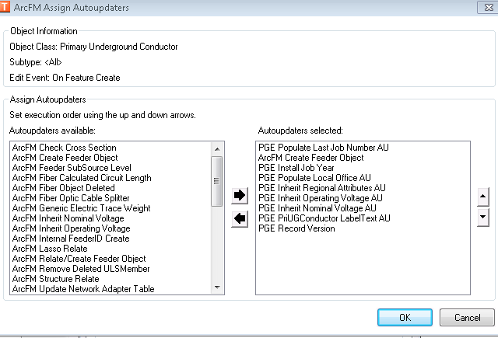

## Add the value ‘5’ and ‘24’ at ‘capbank unit count’ Domain

1. Gain exclusive access to the environment
2. Open ArcCatalog
3. Connect to EDER database as EDGIS user.
4. Right click on database connection and click on properties.
5. Navigate to Domains
6. Select the domain name ‘CapBank Unit Count’.
7. Add the ‘5’ and ‘24’ value and click on apply and OK button

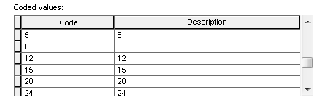

1. In ArcCatalog right click anywhere on the main toolbar and select Customize…
2. Select the commands tab
3. Click on the ‘Add from File’ button
4. Browse and select the DomainSort.dll that is in the ‘Sort_a_domain\Visual_Basic’ directory of the release folder
5. From the 'Developer Samples' commands category, add the 'DomainSortCmd' command to an existing toolbar or the context menu for a geodatabase.
6. Use ArcCatalog to browse to the EDER database to sort a domain from.
7. Click on the command to bring up the dialog, and make choose below parameters for the sort.

Available Domains: - CapBank Unit Count

Sort Type: - Ascending

Sort Item: - Description



1. Click on Ok.
2. Copy Domain.XML file that is in the ‘ED50’ directory of the release folder and paste/replace into ED50 installation folder where Domain.XML file is already exit in all Production/QA Servers.
3. Copy Domain.XML file that is in the ‘ED 006’ directory of the release folder and paste/replace into ED006 installation folder where Domain.XML file is already exit in all Production/QA Servers.

## Assign the split properties for ArcFM to all network devices

**List of objects:**

* capacitorbank
* dcrectifier
* deliverypoint
* dynamicprotectivedevice
* electdistnetwork_junctions
* electricstitchpoint
* faultindicator
* fuse
* openpoint
* primarygeneration
* primarymeter
* primaryriser
* secondarygeneration
* secondaryloadpoint
* servicelocation
* smartmeternetworkdevice
* stepdown
* streetlight
* switch
* tie
* transformer
* voltageregulator

1. Open ArcCatalog
2. Connect to the database to be updated as EDGIS
3. open the electric dataset
4. for each object below, do the following steps:
   1. Select an object
   2. Right click
   3. Choose the ArcFM Properties option
   4. Choose the Object Info tab
   5. Set the "Split On Edit" to Yes
   6. In the same tab assign the ArcFM Segment Split AU to the On Feature Create event.

NOTE: If there is already an AU on the event, select the MULTIPLE option and then assign the new AU along with the existing AU

**\*For the “electdistnetwork_junctions” do not assign the AU, only assign the "Split on Edit" = Yes value.**

# Create Generation Tables

1. Copy the “add_generationtables_to_db.py” python script locally.
2. Edit the file to point to the correct SDE connection.
3. Execute the script.
4. Copy the output into a log file and attach it to the TFS ticket.

# Create Relationships Required for Generation Changes

## Service Point to Generation relationship

* 1. Right click the database and select New->Relationship class.
  2. Follow the below screens:  
     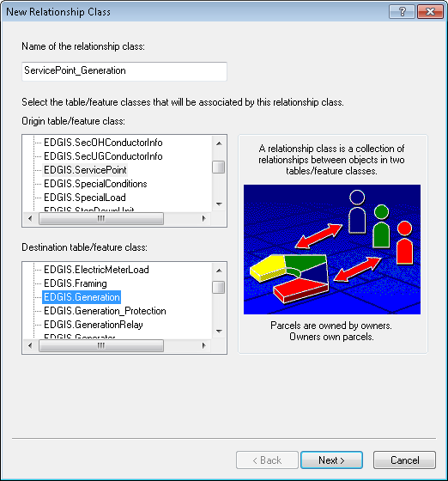  
     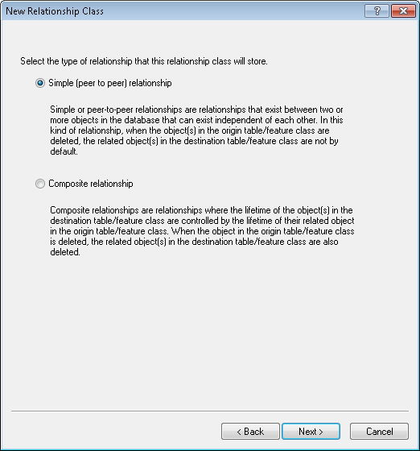  
     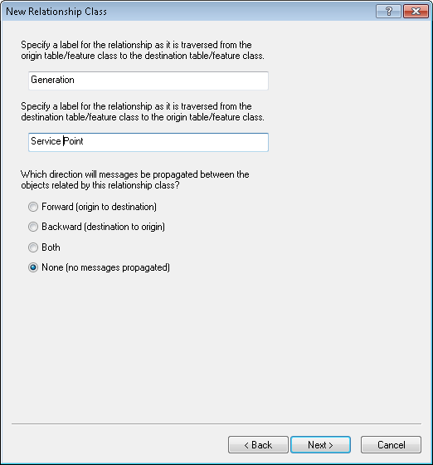  
     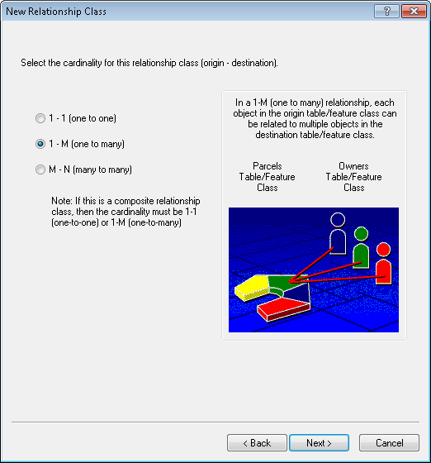  
     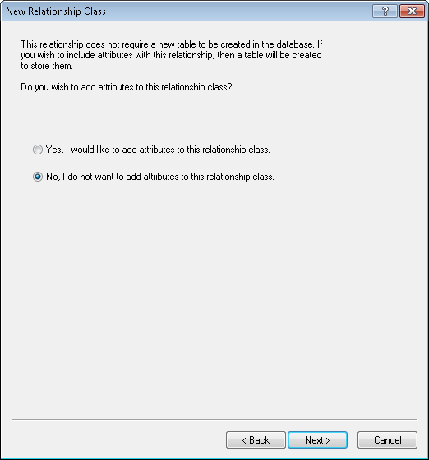  
     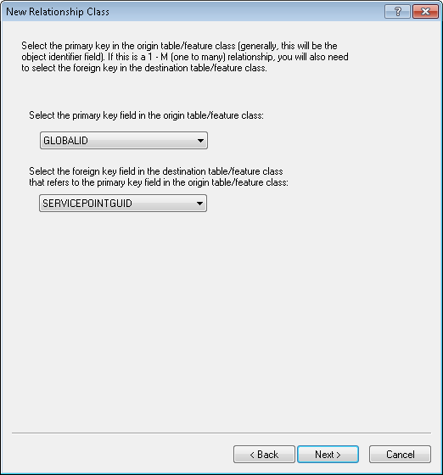  
     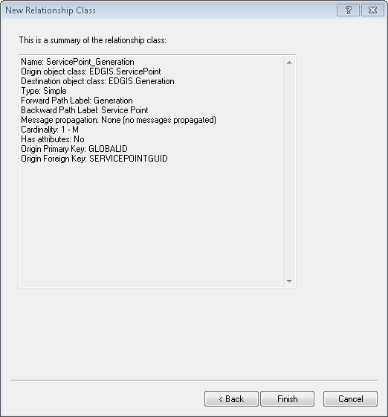
  3. Select Finish to create the relationship.

## Create Relationship Between Generation and Generation Protection

1. Right click the database and select New->Relationship Class.
2. Fill in the attributes as follows:
   1. Name: Generation_GenerationProtection
   2. Origin: Generation
   3. Destination: Generation_Protection
   4. Simple relationship
   5. Forward label: Generation Protection
   6. Backward label: Generation
   7. No message propagation
   8. 1:M cardinality
   9. The relationship is not attributed
   10. Primary key: GENERATIONID
   11. Foreign key: GENERATIONID  
       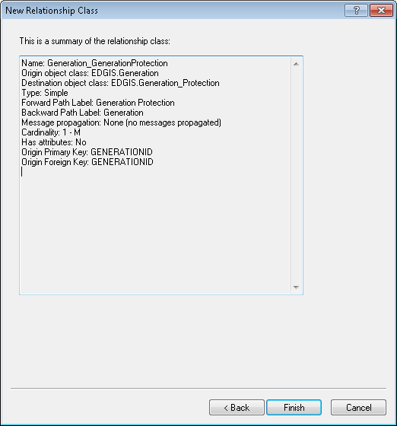
3. Review the details and click Finish.
4. Double click the relationship class and select the Rules tab.
5. Select the origin table subtype Generation.
6. Check the box next to the destination table subtype, Generation_Protection, and select it also.
7. Check the Origin Cardinality box and also the Destination Cardinality box.
8. Set the origin max=1, min=1 (in that order).
9. Set the destination max=9999, min=1.  
   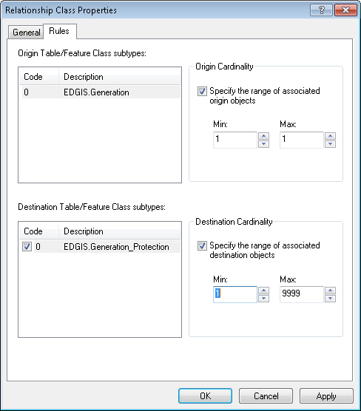
10. Click OK to accept.

## Create Relationship between Generation_Protection and DCGeneration

1. Right click the database and select New->Relationship Class.
2. Fill in the attributes as follows:
   1. Name: GenerationProtection_DCGeneration
   2. Origin: Generation_Protection
   3. Destination: DCGeneration
   4. Simple relationship
   5. Forward label: DC Generation
   6. Backward label: Generation Protection
   7. No message propagation
   8. 1:M cardinality
   9. The relationship is not attributed
   10. Primary key: PROTECTIONID
   11. Foreign key: PROTECTIONID  
       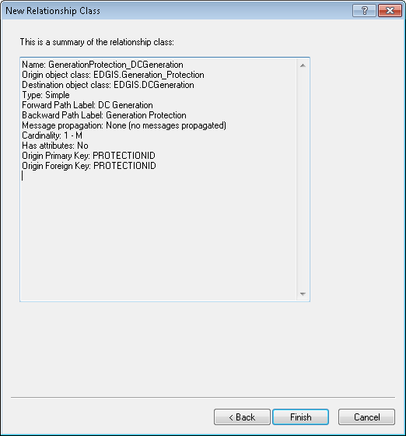
3. Review the details and click Finish.
4. Double click the relationship class and select the Rules tab.
5. Select the origin table subtype Generation_Protection.
6. Check the box next to the destination table subtype, DCGeneration, and select it also.
7. Check the Origin Cardinality box and also the Destination Cardinality box.
8. Set the origin max=1, min=1 (in that order).
9. Set the destination min=0, max=9999.  
   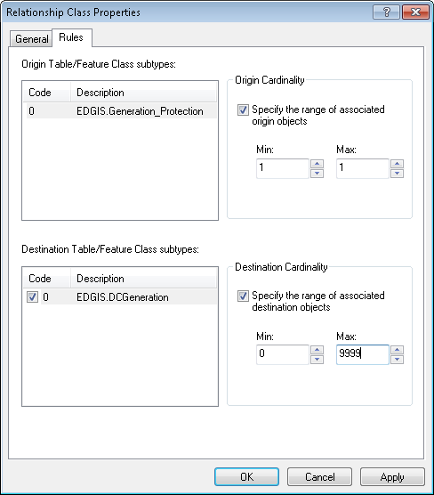
10. Click OK to accept.

## Create Relationship Between Generation_Protection and InverterTR

1. Right click the database and select New->Relationship Class.
2. Fill in the attributes as follows:
   1. Name: GenerationProtection_InverterTR
   2. Origin: Generation_Protection
   3. Destination: InverterTR
   4. Simple relationship
   5. Forward label: Inverter TR
   6. Backward label: Generation Protection
   7. No message propagation
   8. 1:M cardinality
   9. The relationship is not attributed
   10. Primary key: PROTECTIONID
   11. Foreign key: PROTECTIONID  
       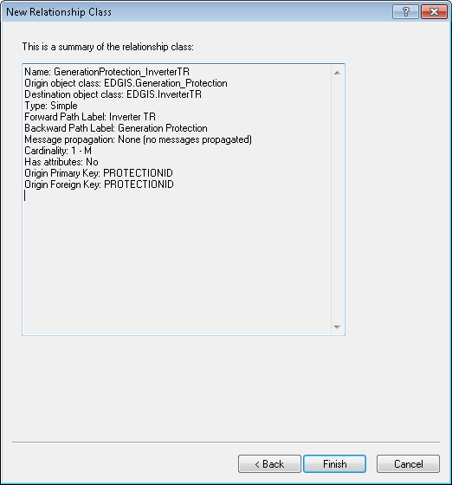
3. Review the details and click Finish.
4. Double click the relationship class and select the Rules tab.
5. Select the origin table subtype Generation_Protection.
6. Check the box next to the destination table subtype, InverterTR, and select it also.
7. Check the Origin Cardinality box and also the Destination Cardinality box.
8. Set the origin max=1, min=1 (in that order).
9. Set the destination min=0, max=9999.  
   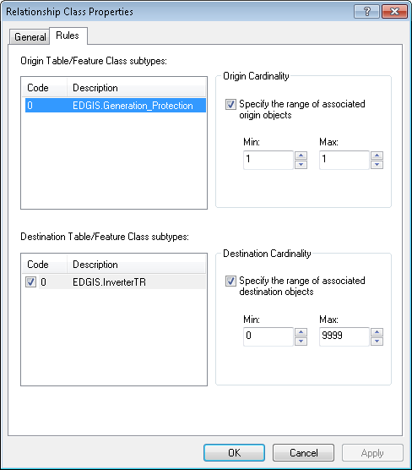
10. Click OK to accept.

## Create a Relationship between Generation_Protection and InductionGeneration

1. Right click the database and select New->Relationship Class.
2. Fill in the attributes as follows:
   1. Name: GenerationProtection_InductionGeneration
   2. Origin: Generation_Protection
   3. Destination: InductionGeneration
   4. Simple relationship
   5. Forward label: Induction Generation
   6. Backward label: Generation Protection
   7. No message propagation
   8. 1:M cardinality
   9. The relationship is not attributed
   10. Primary key: PROTECTIONID
   11. Foreign key: PROTECTIONID  
       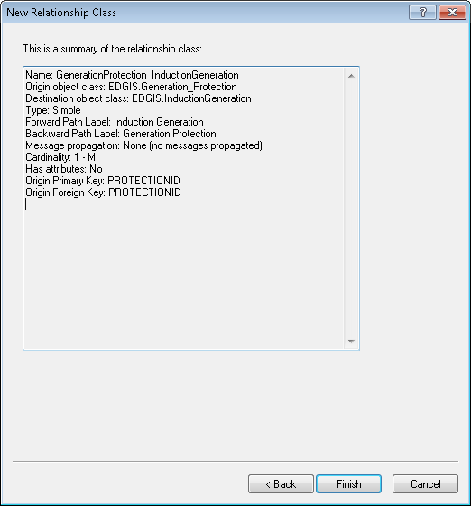
3. Review the details and click Finish.
4. Double click the relationship class and select the Rules tab.
5. Select the origin table subtype Generation_Protection.
6. Check the box next to the destination table subtype, InductionGeneration, and select it also.
7. Check the Origin Cardinality box and also the Destination Cardinality box.
8. Set the origin max=1, min=1 (in that order).
9. Set the destination min=0, max=9999.  
   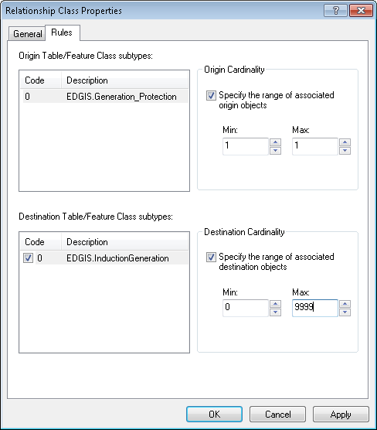
10. Click OK to accept.

## Create a Relationship between Generation_Protection and SynchronousGeneration

1. Right click the database and select New->Relationship Class.
2. Fill in the attributes as follows:
   1. Name: GenerationProtection_SynchronousGeneration
   2. Origin: Generation_Protection
   3. Destination: SynchronousGeneration
   4. Simple relationship
   5. Forward label: Synchronous Generation
   6. Backward label: Generation Protection
   7. No message propagation
   8. 1:M cardinality
   9. The relationship is not attributed
   10. Primary key: PROTECTIONID
   11. Foreign key: PROTECTIONID  
       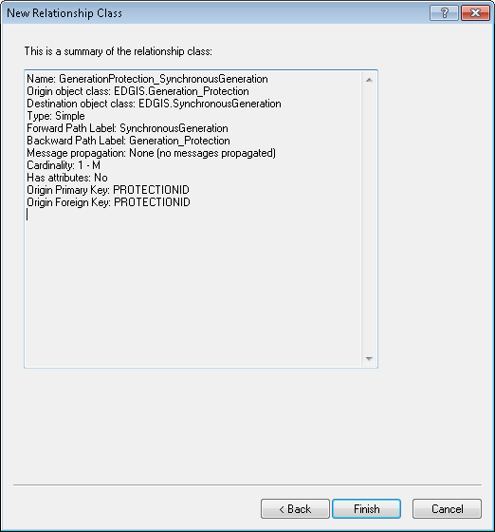
3. Review the details and click Finish.

## Create a Relationship between Generation_Protection and GenRelay

1. Right click the database and select New->Relationship Class.
2. Fill in the attributes as follows:
   1. Name: GenerationProtection_GenRelay
   2. Origin: Generation_Protection
   3. Destination: GenRelay
   4. Simple relationship
   5. Forward label: Generation Relay
   6. Backward label: Generation Protection
   7. No message propagation
   8. 1:M cardinality
   9. The relationship is not attributed
   10. Primary key: PROTECTIONID
   11. Foreign key: PROTECTIONID  
       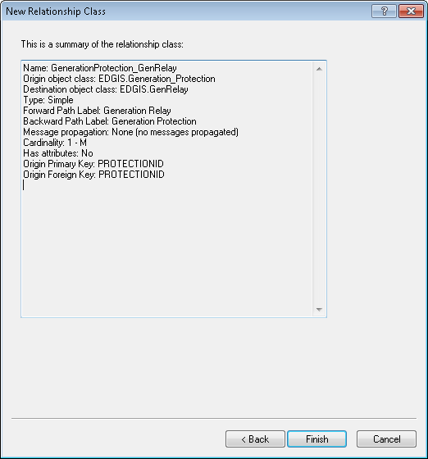
3. Review the details and click Finish.

# Data Model Version Table

**Database Configuration:**

1. Open SQL Plus.
2. Log in using the same server and user as was used in section 2.  
     
   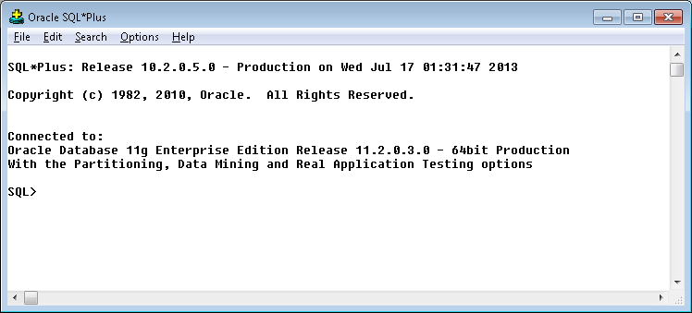
3. Run the SQL below:

update pgedatamodelversion set currentidc='N' where currentidc='Y';

insert into pgedatamodelversion (OBJECTID, CURRENTIDC, DATEAPPLIED, APPLIEDBYPERSONNAME, MODELVERSION) values (**INSERT NEXT VALID ID**,'Y',sysdate,'**<INSERT TEAM MEMBER DONE BY>**','**<INSERT DM VERSION>** GOLD **CR<INSERT CR NUMBER>**');

commit;

# Known Issues

<Please List any other issues encountered here while following the document>